UNIVERSITY OF BIRMINGHAM
Liberal Arts and Natural Sciences

Student ID No: 1550700
Module title:
Module banner code: |  | Word Count*
Module leader:
Submission date:
Assignment title:
Extension: | yes | date approved: 27/03/2019
Extension approved by: Ruth Johnson |  | new date: 13/04/2019
I do (please delete as appropriate) wish my assignment to be considered for including as an exemplar in the School Bank of Assessed Work
10,797
*Word Count: should not include coversheet, essay title, data in tables, the bibliography and any appendices.

Important Assignment Related Notices
Assignment Grades:
Any mark awarded for an assignment will be made of a step grade of either 2, 5 or 8 over the mark range (unless you have had marks deducted for unauthorised late penalties). All marks are provisional until ratified by the exam board.
Penalties:
University policy requires that a penalty be deducted from the actual mark achieved for each working day the assignment is late until 0 is reached. There is a strict deadline of 11:59pm on day of submission. 5 marks will be deducted for every 11:59pm deadline that is missed. Any written assessment that exceeds the stated word limit by more than 10% will receive a 5 mark deduction.
Extensions & Plagiarism Information:
For more information about extensions and plagiarism please refer to your CANVAS LANS Hub. An Originality Report (OR) is generated by Turnitin every time a piece of work is submitted. Please note that all assignments will achieve a OR score due to the use of standard coversheets.
C. Canvas Assignment Discussions
Canvas provides a Discussion Area for each assignment. Both staff and students can leave messages in this area. Please ensure that all communication is undertaken in a professional and polite manner. Remember that electronic discussions do not have the benefit of the nonverbal and vocal cues that normally convey meaning in a traditional face-to-face conversation. Satire, sarcasm and “heat of the moment” feelings can come across as rudeness. Please check your tone before you post a Comment.
Please make an appointment within advertised office hours in the first instance to discuss any matter of assignment feedback and grading. It is policy that staff will not be actively engaging in debate over matters of feedback and grades with individual students via Canvas’ online Speed Grader system.

Liberal Arts and Natural Sciences with a Major in Biological Science

University of Birmingham

Understanding microplastics and artistic communication: scientific poster versus painting
ID number: 1550700
Date: 28/03/2019
Supervisors: James Everest & Iseult Lynch

Contents:
Acknowledgements
Abstract
Introduction
Art as a communication tool:
A multidisciplinary approach
Literature review
Case study of Microplastics
Microplastics:
Literature review
Primary data
Results
Conclusion
Study:
Introduction/set up
Controls/method
Results
Discussion
Conclusion
Appendix A
References

Acknowledgements:
I would like to thank James Everest and Iseult Lynch for their help forming this dissertation and to everyone who gave me feedback or supported me during the research. I am also grateful to the staff of the Liberal Arts and Natural Sciences department of the University of Birmingham, who allowed me the intellectual (and at times physical) space I needed to explore my ideas.

Abstract:
A multidisciplinary dissertation investigating fine art as a method of communication about the case study: microplastics and human health. Findings suggest that microplastics have potential to cause health problems due to the leaching of toxic chemicals, over 8% of an educated western sample had never heard of microplastics before and over 30% of participants reported that a painting was a more effective form of communication than a scientific poster on the same topic of microplastics and human health, opening up areas for further study into communication through art.

Introduction:
The focus of my interdisciplinary dissertation is to investigate the extent of preference for art as a form of communication to the general public. I do this through academic review as well as collection of primary data which allowed me to identify gaps in knowledge and test arts ability to convey information through use of a case study: Microplastics and Human Health.
Through collection of primary data and analysis of the current academic research, I have identified a need for increased communication about microplastics and human health, as well as evaluated the risks they pose to humans. The sustained research I have conducted (including survey and anthropological study), seeks to fill spaces in understanding about the public’s knowledge of microplastics as well as solidify hypotheses that art acts as a valuable form of communication. Areas opened by the research include those which explore individual preference as a factor for art processing and those which explore multidisciplinary approaches to the subjects of art and communication as well as microplastics.
Art as a Communication tool: A multidisciplinary approach
Art’s ability to communicate has fascinated humans for many years, but it is a topic of empirical research that ‘has only grown in the last decade’ (Jacobsen, 2006; Mandelbrojt,1994; Pelowski et al, 2016). Art has the capacity (and some would argue, the necessity) to influence its viewer’s emotional state (Chatterjee, 2011; Tolstoy, 1899; Vessel et al, 2012) physiology (for example pupil dilation) (Tschasher et al, 2012) and long-term understandings of the world (Berger, 1972; Finnegan, 2002; Lasher et al, 1983; Pelowski & Akiba, 2011). The mechanisms by which it does this are discussed across multiple disciplines, including psychology, neuroaesthetics, business, evolutionary biology, linguistics, art history, philosophy and artistry, but as yet, no one knows exactly how it works (Collingwood, 1938; Pelowski et al, 2016; Miller,1999; Helmut, 2013; Kant, 1978; Jeong, 2008; Berger, 1972; Mantovani & Tazima, 2016; Magritte, 1929). Investigating how art communicates is crucial to understanding human cognition and may provide public benefits to education practices as well as businesses (Barter & Tregidga, 2014; Jeong, 2008; Krause, Ruxton & Krause, 2010). This can be seen through the effects art and aesthetics have in shaping consumer behaviour (Mantovani & Tazima, 2016; Jeong, 2008; Lee, 2013) as well as our perceptions of self and those around us (Berger, 1972).
If one considers, like Spinoza, that art perception is the product of the mind "Man's judgement is conditioned by the make-up of his brain” then, due to the limits to our current understandings within the fields of neuro-cellular biology and human evolution, no one theory of art as communicator can be entirely without flaw (Liu et al, 2017; Mandelbrojt, 1994). Variance in methodology (for example regarding the degree of control or generalisability of the studies used) make it difficult to form a holistic understanding of the topic (Jacobsen, 2006) or produce ‘mathematical models’ of art communication (Liu et al, 2017). However, due to the complexity of the topic, engaging with multiple approaches to art offers potential to explore its communicative abilities (Jacobsen, 2006; Tregidga, 2014). In this dissertation, I evaluate theories from a range of fields in order to form an understanding of visual art and communication as well as dismantle “unnecessary barriers” between disciplines (Ingold, 2018; Jacobsen, 2006; Pelowski, 2016). Whilst by no means seeking to reduce art in its entirety to ‘mere aesthetic processing’, visual art is an area that has potential for easy empirical study and comparison across disciplines and as such I shall focus on it specifically (Brown, 2019).
I respond to a gap in knowledge concerning whether artistic or non-artistic media is preferred by viewers when acquiring new information (Leder et al, 2013). I do this through use of a case study on a topic that needs clarification: microplastics and human health (Pelowski, 2016). After reviewing the literature on both artistic communication and microplastics and human health, I utilize both a scientific and artistic mechanism to communicate about the issue. Sperber and Wilson argue that art communication is composed of two modes, that of ‘making’ and of ‘experiencing’ (Sperber & Wilson, 1996). The literature I investigate in this dissertation primarily considers the experience side of art, focusing on the cognitive and biological mechanisms behind its ability to communicate, whilst ‘the making’ aspect is explored through the production of a fine art painting and an academic-style research poster. I finish the dissertation with a discussion of my findings through the lens of some of the communication models approached within the dissertation.
Art as communication: Literature review
Evolutionary biologists attempt to explain behaviour based on the understanding that a trait persists within a species if it provides an adaptive advantage (or no strong disadvantage) (Leder & Nadal, 2014). Some evolutionary biologist argue therefore that art is an adapted trait which has evolved due to its ability to provide social benefits (it may help to identify individuals, indicate social ties, and intimidate rivals) (Appenzeller, 1998; Zahavi, 1978). The idea that artistry has evolved is supported by research which highlights that creativity has (an at least partial) genetic basis, and could therefore be genetically selected for (a poly- morphism of the promoter region of the neuregulin 1 gene has been found to be associated with increased creativity in some individuals, for example) (Kéri, 2009). Further evidence that art is an adaption comes from studies which show that those who engage with cultural activities have better physical and mental health than those who do not and that fine art has been found to increase a sense of satisfaction in viewers (Chatterjee, 2004; Cuypers, 2012; Leder et al, 2013; Lewis, 1995; Vessel et al, 2012). Some argue that art acts like a ‘medicine’ for humans through its cathartic properties (Lewis, 1995). However, this does not explain why it should improve health and as it has been found that non-human species have artistic capabilities which do not seem to provide them with any selective advantage (artworks have been produced by Neanderthals and by a chimp named ‘Congo’) the mystery of how it evolved remains uncertain (Morris, 2013; Appenzeller, 1998). Furthermore, variables such as income may have a significant impact on data about those who visit galleries versus those who do not making the impact of art on health hard to determine.
Another branch of evolutionary biology investigates the spread of creative and non-creative personality types within a population rather than on an individual basis, arguing that creative individuals in a group enable the population as a whole to produce better technology and solve problems more innovatively (Krause et al, 2010). Artistry, even if it does not always confer direct fitness to the creator, is therefore a trait that can be beneficial to the population. This might explain the evolutionary benefit to having diverse personality types in a group, but it does not explain why the creative trait becomes directed towards seemingly unhelpful tasks that rarely benefit anyone’s fitness directly (e.g. painting) (Davies, 2012). Furthermore, for this group model to apply, the opinions and talents of all individuals must also be given equal weighting and there cannot be ‘systematic bias’ towards a specific group or individual (Kerr & Tindal, 2004). As the required egalitarianism of this model does not always persist within human groups (and some creative individuals may even be ‘crushed’ due to their difference rather than used to benefit the group) the creative group hypothesis is certainly flawed (Krause et al, 2010). The simple averaging of a groups intelligence or creativity may not even be the most valuable use of highly skilled individuals in an adaptive sense (Krause et al, 2010).
Those who reject the notion that art has a direct benefit to humans, see it as an effortful activity without a strong evolutionary benefit (Rees, 2013; Miller, 1999; Davies, 2012). The benefits of viewing and engaging with art are so subtle that it is difficult to assess how they would lead to increased survival/ have evolved specifically (Mandelbrojt, 1994). Some evolutionary biologists argue that the only explanation for energy inefficient artistic behaviour is that it demonstrates fitness in a sexual context (Crocchiola, 2014; Miller, 1999). This is known as the ‘cultural courtship model’ (Miller, 1999). The theory argues that females select male mates who are successful in creating beautiful and difficult pieces of art, because the ability to use tools such as language and image in novel ways, indicates that the artist is more intelligent and apt at communicating than another potential suiter (Harper, 2016; Miller, 1999). In this way, art is described as like a bird feather, its colouration indicating health and vivacity to the opposite sex (Harper, 2016; Miller, 1999). According to the model, females select males with brighter feathers and the genes for those traits are passed to the subsequent offspring (as well as in female offspring, attraction to such traits) (Miller, 1999). The model may explain why audiences often feel unimpressed when artworks do not display a technical skill, because such art does not discernably indicate the fitness or ability of the maker (Miller, 1999).
Some scientists use this model to explain the saturation of the art world with male artists, likening the disparity between male and female artists represented in galleries to a sexual dimorphism between the male and female of a bird species (Crocchiola, 2014; Miller, 1999). This neglects the impact of social and economic gendered inequality (Woolfe, 1929; Millar, 2011; Guerrilla Girls, 2011) and also does not account for findings which suggest that men experience more positive benefits from visiting galleries than women (despite the majority of art in galleries being produced by men) (Cuypers et al, 2012). Furthermore it ‘over-simplifies the human mate selection processes’, by assuming that only the female choice is important in mate selection (Stewart-Williams & Thomas, 2013). Without a strong link between art and fitness, artistic behaviour appears to be an accident of increased cognition (Morris, 2013). If art and artistic appreciation can emerge in animals despite providing no direct fitness, it might suggest that arts origins are less of a direct selection based on fitness or sex, but rather as an accident or ‘invention’ based on selection for other traits such as intelligence or empathy (Appenzeller, 1998; Morris, 2013).
Investigating how art is perceived and interpreted within the brain may help to unlock exactly how it is able to communicate (Leder et al, 2013). Shannon and Weaver (1949) suggest that art is a mode of communication with inputs and outputs (a little like a message from one end of a telephone to the ear of someone else) (Shannon& Weaver, 1949). This argument suggests that communication is a case of transferring information from one person to another and that noise and different modulation processes all add up to the relay of a message (Shannon & Weaver, 1949). According to Sperber and Wilson (1996), this theory became ‘entrenched in western thought’ with its claims that art communicates in much the same way a language does. During the transfer of information, three issues are addressed: the technical (how accurately the symbols of communication are transmitted), semantic (how precisely the desired symbols convey the information) and effective (how successfully does the desired meaning affect the receiver's conduct) (Shannon & Weaver, 1949). A diagram of how the process of communication occurs according to Shannon and Weaver (1949) can be seen in figure 1.
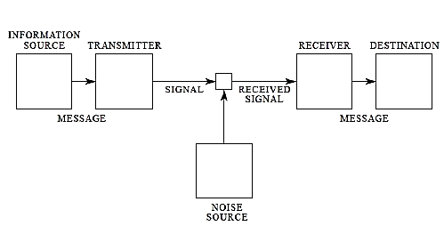
Figure 1. The communication of information from Shannon and Weaver (1949)
If we apply this model to art, the information source=the brain, the transmitter=the art, signal=wavelengths of light the receiver the eye of the viewer, destination being the brain of the viewer. Noise could include disturbance due to lighting, or even the viewers own cognitive processes.
This approach considers communication and art as that which carries a specific intention or message, but ignores the value of subtleties, intuition and the accidental expressions that occur frequently during artistic communication (Finnegan, 2002; Sperber, 1996). In Mandelbrojt’s 1994 cross-disciplinary review of art and aesthetics he states that “a painting offers a plurality of meanings and is coded in many ways”, suggesting that art is more than just a direct relay of information (because we have code and language for this).The model does not explore factors such as emotional state, preconceptions or context, and also fails to account for prior knowledge that is often required to understand art (for example, when viewing art based on myth or religious stories, one requires understanding of the culture in order to successfully interpret the symbolism) (Mandelbrojt, 1994). To improve on this ‘old’ mathematical model as originally designed in 1949, scientist Dan Sperber and linguist Deirdre Wilson design their own cognitive model of communication (Sperber & Wilson, 1996).
Sperber & Wilson argue that art functions in two ways: one, as a direct code or message from the artist to the viewer (like that illustrated by Shannon and Weaver), and the other, through inference (Sperber & Wilson, 1996). Sperber and Wilson argue that artistic experiences involve an artist modifying the perceivable environment and the viewer subsequently interpreting it (Sperber & Wilson, 1996). This process occurs whether the piece of communication has a coded meaning (for example a simple sentence) or not (Finnegan, 2002; Sperber & Wilson, 1996). Subsequently, the ‘cognitive set of facts’ that a viewer is able to infer about the world (based on their past experiences, mood and cognitive abilities) can be subtly shifted during the viewing of art, leading to the changes in perception and world view that it is known to illicit (Finnegan, 2002; Pelowski, 2016; Sperber & Wilson, 1996). Sperber and Wilson argue that arts ability to alter perception could have an adaptive benefit, which means that their theory could potentially complement adaptive theories of artistic evolution (Sperber & Wilson, 1996).
A more recent line of thinking to that of Sperber and Wilson, comes from the field of psychology and neuroaesthetics, with a key model being the ‘information processing flow model’ (Leder et al, 2013). This cognitive model seeks to illustrate how art forms ‘socially meaningful’ experiences through the modulation of different forms of mental processing (Leder & Nadal, 2014). It argues that the communication of art consists of a “distributed neural network of activation in the brain” and like many models within neuroaesthetics, suggests that art viewing involves structured mental processes, including observation, processing and evaluation (Leder et al, 2004; Leder et al, 2013; Liu, et al, 2017). Most models within neuroaesthetics agree that the output of artistic experience is ‘emotion and evaluation’ (Pelowski et al, 2016). When art is experienced, it is first observed as a stimulus (e.g. a visual input), then processed within the brain according to its style, content, and several other factors (including mood, personal taste and previous experiences), and finally evaluated, with the result being the formation of an evaluation and emotional assessment of the piece (Leder et al, 2004). According to cognitive models, when art is viewed, the brain is stimulated to perceptive the rest of its environment slightly skewed, resulting in a shift in personal outlook (Leder et al, 2013; Pelowski & Akiba, 2011; Sperber & Wilson, 1996).
Processing is not a linear occurrence according to neuroaesthetic models, but one which involves a “continuously ongoing emotional evaluation” of the material under observation (Leder & Nadal, 2014). Different models place various levels of importance on each factor with a combination of automatic and deliberate cognitive functions occurring throughout (meaning both unconscious and conscious) (Leder & Nadal, 2014; Pelowski et al, 2016). Augustin et al, (2008) found that the subject of an image is processed before the style and therefore the subject of a piece and its content might appear a more important consideration for the brain than its aesthetics. However, a study by Nadal et al in 2010 found that artworks were generally deemed more beautiful than non-artworks, indicating that the overall judgement of the piece favoured artistic imagery over the content of the piece. The way in which the artwork is considered by the viewer can even influence whether art will illicit a shift in world view or perception, as Cupchick et al, (2009) found that if art is percieved for its aesthetics, then an area of the brain known as the bilateral insula is engaged, but if it is understood pragmatically, then this does not occur, and instead the right fusiform gyrus is engaged. Art must be understood as art in order to be processed emotionally because specific areas of the brain are seen to process art in specific ways (Critchley et al, 2004; Cupchick et al, 2009).
Figure 2 illustrates the different inputs that influence the viewers overall assessment of art:

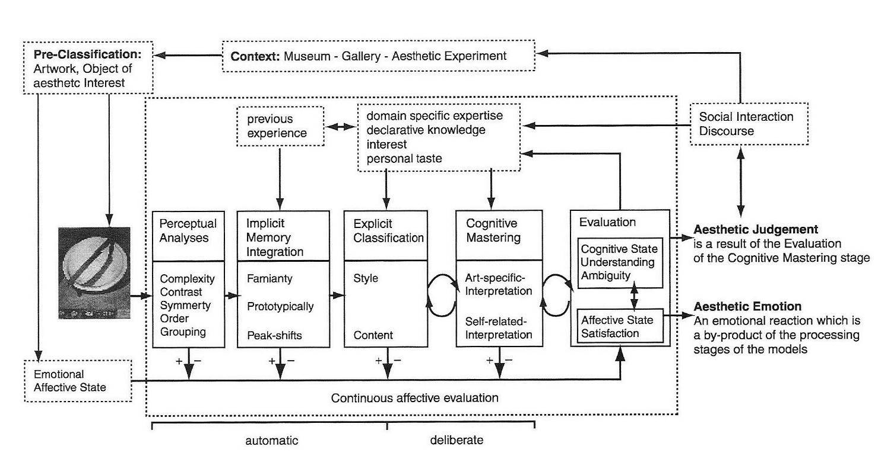
Figure 2. A diagram of ‘The information processing flow model of aesthetic experience’ which describes how art comes to be perceived and evaluated. From Leder et al, (2004).
The information processing flow model successfully accounts for the influence of emotion within the artistic experience (Pelowski, & Akiba, 2011; Vessel et al 2012) and argues that contextual and personal factors are important to the evaluation of art as well as the nature of the piece itself (Cupchick et al, 2009; Leder et al, 2004; Pelowski & Akiba, 2011). This is supported by research from advertisers and scientists alike who have found that use of metaphorical imagery, colour, setting of the art viewing, inclusion of text, contrast levels within paintings and subject matter are all important in artistic ‘information processing’ supporting the information processing model of art communication (Jeong, 2008; Cupchick et al, 2009; Pelowski & Akiba, 2011; Ritson, & Elliot, 1999; Vessel et al, 2012) . Both Shannon and Weaver and the psychological models of art communication consider cognitive processing over time to be a key feature of art communication and value the importance of ‘noise’ (variables besides the art’s aesthetic) on how art is perceived (Shannon & Weaver, 1949; Leder & Nadal, 2014). Sperber and Wilson also describe the importance of context from a linguistic perspective (through use of the term relevance) demonstrating that multiple models can fit within the cognitive framework to explain how art communicates to its audience (Sperber & Wilson, 1996).
Information processing approaches fail to provide an evolutionary basis for aesthetic appreciation (Leder & Nadal, 2014) or address how exactly processing occurs in the brain (individual neural patterns being difficult to ascertain with current technology and understandings of neuro-cellular biology) (Pelowski et al, 2016). Furthermore, the combining of multiple pieces of research within one model has the potential to destroy the ‘major theoretical benefit’ of such an approach, namely the clear connections ‘between inputs, processes, and outputs’ that it describes (Pelowski et al, 2016). Cognitive approaches do, however, make attempts to explain arts propensity to stimulate schematic shifts that are ignored by other approaches such as evolutionary biology and mathematical models (Pelowski & Akiba, 2011). 27 areas have been linked to art perception (Liu et al, 2017), The exact value of the shifts in perception caused by art in comparison to that which occurs during the viewing of non-artistic media has not been quantitatively examined.

Based on my literature review, cognitive and psychological models of art communication attempt to address the ‘how’ of art, whilst evolutionary biologists make theories to explain why it evolved in the first place. Many studies sought to understand how art was perceived as beautiful, or pleasing, but few investigated its ability to communicate direct meaning. I saw a need for further bridging between models such as that from Sperber and Wilson, and those from neuaroaesthetics (the information processing flow model). Leder states that there are four major areas in neuroaesthetics in need of investigation: the emotional component, the role of context, the neural underpinnings of aesthetic experience, and art’s evolutionary origin (Leder and Nadal, 2014). He also suggested in 2013 that there is a lack of research into art vs non art communication (Leder 2013). I was curious to investigate whether the artistry of a visual stimulus was implicated in its ability to communicate information successfully, and if so, by how much.
Art as Communication: Case study
Successful ccommunication is often achieved creatively, as can be seen through the mass popularity of informative documentaries such as Blue Planet 2 that depict information about the natural world as entertainment (BBC News, 2017). Artists have communicated about the world for years and many organisations today attempt to bridge the art and science world for the benefit of each (Curtis et al, 2012). In 2018 for example, Artist Olafur Eliasson and geologist Minik Rosing imported sea ice from Greenland to create an artwork which highlighted the reality of global warming (Tate, 2018). As it would be far cheaper to display a huge sign reading: ‘Global warming exists’, the value of art is apparent. Art has been used to in social action and protests for many years, including to criticize art itself (Lee, 2013/ Guerilla Girls, 2011). Surprisingly however, its communicative power is rarely proved quantitatively, or assessed in contrast to a more literal way of communicating. To validate arts ability to relay information, I sought to compare the efficiency of a painting against that of a poster on the same topic.
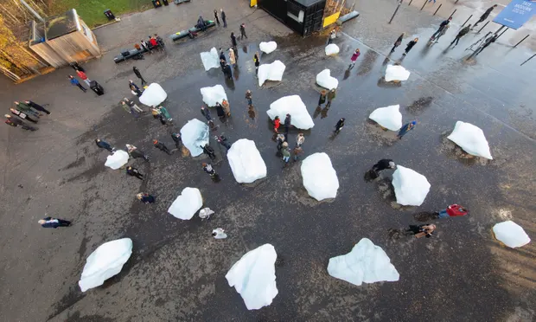
Figure 3. Ice sculpture by Olafur Eliasson and Minik Rosing in London, from the Guardian (2018, Nov 11).
I found inspiration in news headlines about microplastics and determined that it would be a topic I wanted to explore communicating as a case study. A brief search through news headlines revealed that microplastics (and in particular, their effects on human health) were a topic of uncertainty: “The possible health effects [of microplastics] on people and ecosystems have yet to be determined” (Carington, 2019). Both the European Food Safety Authority and the UK Government launched independent investigations into the effects of microplastics on health in 2016 and 2018 respectively (European Food Safety Authority, 2018; House of Commons, 2016) whilst headlines such as “Microplastic pollution revealed ‘absolutely everywhere’ by new research” and “Microplastics have been found in humans for the first time. It’s a worry” stress that they have become an area of public concern (Carington, 2019; Knapton, 2018). As I dug deeper, even the United Nations appeared concerned about the health effects of microplastics (“Microplastics in the sea a growing threat to human health, United Nations warns”) (Forster, 2016). I wanted to discern whether a painting could transfer information about microplastics and whether artistry was helpful in communicating. In order to do this, I needed to first understand the topic fully.
Microplastics are plastic fragments below 5 mm or 5000 micrometers in length (Pico et al, 2018) but also sometimes defined as plastics below 1 mm in length (Free et al, 2018). They can be categorised by the type of materials that make them up (Polystyrene, Polyethylene and Polypropylene being among the most common), as well as by their structure (for example, pellet, fibre or granule), and whether they are primary (created specifically at that size) or secondary microplastics (exist as the result of degradation of other plastics, for example as tires are worn down on roads or synthetic fibres washed out of clothing) (Galloway, 2015; Rist et al, 2018). The prevalence of microplastics has risen across the globe so that they are now considered ubiquitous, yet their impacts on humans are largely ‘unknown’ (Pico et al, 2018; Rist, 2018).
Microplastics have been found within animals from shallow and pelagic waters (Ding et al, 2018; Jabeen et al, 2017; Sanganyado et al, 2018; Van Cauwenberghe & Janssen, 2014) and the deep sea (Wieczorek et al, 2018), as well as within bottled and treated water (Oβmann et al, 2018; Pivokonsky et al, 2018), the air (Horton et al, 2017; Li et al, 2018), agricultural sludge (Li et al, 2018) and even our own digestive systems (Clarke, 2018; Harvey & Watts, 2018). The reliability of studies investigating microplastic prevalence is mixed, as some do not provide controls for contamination that leads to invalid data (Rist et al, 2018). It can also be difficult to compare studies due to a lack of defined methodology for researching microplastics (Pico et al, 2018). However, there are multiple sources suggesting that they permeate almost all features of the biosphere, including remote habitats (such as the isolated freshwater of a Mongolian lake) (Carington, 2019; Free et al, 2014). The omnipresence of microplastics within the environment suggests that the issue of whether they impact our health is relevant to everyone (Li et al, 2018) and as microplastics resist biodegradation, particularly within aquatic environments, they are an issue that may well persistence within the biosphere (Alfarhan, & Barcelo, 2018; Pico et al, 2018). The potential harm and longevity of such particles, coupled with the prevalence of concerning headlines, indicate that the topic of microplastics and human health is one worth clarifying (Lithner et al, 2011; Pico et al, 2018; Sanganyado et al, 2018). In order to do this, I collected primary and secondary data about how microplastics are viewed and about their potential to impact health.
Microplastics and Human health: Literature review
Due to drastic increases in global plastic production in recent years (global production of plastic increased from 335 to 348 million tons between 2016 and 2017 alone), almost all human communities interact with microplastics on a daily basis (Ahmet et al, 2018; Free et al, 2014; Lithner et al, 2011; Plastics Europe, 2018). The largest sources of human exposure to microplastics come from ingestion and inhalation of microplastics within dust, synthetic clothing fibres (60% of all microplastic) (Pico et al, 2018) and food packaging (Catarino et al, 2018; Galloway, 2015; Horton et al, 2017; Ribeiro et al, 2019). The impacts on human health due to microplastics come from their potential to leach toxic chemicals such as plasticizers, harbour dangerous pathogens, and cause structural damage to cells such as those in the lungs (Kirstein et al, 2016; Lithner et al, 2011; Shafei et al, 2018) however there is no long-term human-based evidence for this as yet (Hoet et al, 2004; Rist et al, 2018). Many non-scientific sources report risks associated with the levels of ingestion via seafood to be of most pressing concern (House of Commons, 2016; Knapton, 2018), however due to the small quantities of microplastics within seafood, this is unlikely to be accurate (Rist et al, 2018).
Studies on rats, in which the animals were fed polystyrene particles revealed that microplastic particles could be taken up by specific cells of the gut and translocated to other organs including the liver, where they were found to cause oxidative stress (damage) (Jani et al, 1992). Although the quantities of such uptake are low (Rist et al, 2018), these studies suggest that the immune cells of the gut could take up microplastics via phagocytosis and that microplastics could enter other organs of the body (Jani et al, 1990). This might therefore occur also in the human digestive system (Jani et al, 1992). Similar findings of microplastic uptake have been reported in mice (Lu et al, 2018) zebra danio (with polystyrene causing liver damage following consumption) (Lu et al, 2016), and the red tilapia fish, which accumulated microplastics in several organ systems including the liver and brain (Ding et al, 2018). Microplastics found within the circulatory system of a dog and within human lymph nodes (in the case of the human, these particles had broken away from a hip prosthesis and proceeded to cause health problems) further indicate that microplastics have the capacity for travel across organ systems (Hicks et al, 1996; Volkheimer, 1977). Microplastics have also been shown to cause physical damage to human lungs when inhaled frequently, (however as the participants providing these data were factory workers, other substances released within this working environment are also implicated in causing the respiratory damage) (Horton, 2017; Prata, 2018).
Microplastics have potential to cause indirect harm to humans due to their carrying of pathogenic bacteria, and the disruption they cause to food chains on which humans rely (specifically those connected with marine life) (Horton et al 2017; House of Commons, 2016 Kirstein et al, 2016; Sanganyado et al, 2018). Although some studies argue that microplastic concentrations in the biosphere has plateaued (Beer et al, 2017), others suggest that microplastics are increasing in prevalence and should be ‘considered as part of environmental risk assessments’ due to the ‘perturbations in biological systems’ such materials cause (Ding, 2018). They have been found to harbour pathogens such as Vibrio parahaemolyticus, which cause gastrointestinal problems, indicating that microplastics could act as transporters of disease in humans and the animals we rely upon (Kirstein et al, 2016; Ribeiro et al 2019). Others argue that the risk of sickness from pathogens carried on microplastics is negligible compared to that of bacteria carried on organic particulates regularly ingested by humans (Rist et al, 2018) and that the human digestive system is adequately adapted to protect against microplastics due to a well-adapted mucosal layer within the gut (Hoet et al, 2004). Furthermore, the numbers of microplastics ingested via seafood are arguably too few to be deemed likely to cause any damage to humans, with around 100 microplastics ingested per year via mussels, but over 13,000 per year from household dust landing on food (Catarino et al, 2018).
Perhaps the best evidence to suggest microplastics/plastics may cause health problems for humans comes from research considering the chemical property of the plastic itself (Galloway, 2015; Lithner et al, 2011). Developing plastics involves the joining of monomers in a process called polymerization (Lithner et al, 2011). During this process, the plastic’s monomers are combined with additives such as plasticisers, pigments and flame retardants to give the product more stable or desirable chemical properties (Galloway, 2015; Lithner et al, 2011). As additives and unset particles within the plastic structure remain unbound to the polymers themselves, they have the potential to leach out into their surroundings (which, following ingestion, could include the cells of the body) (Lithner et al, 2011; Ribeiro et al, 2019). Some of the chemicals used to form plastics are toxic or carcinogenic (Cooper, 2011; Lithner et al, 2011; Shafei et al, 2018). One such chemical is BPA (Bisphenol-A), found within plastics such as Polyurethane (Lithner et al, 2011). BPA mimics the hormone estrogen and is known to disrupt the human endocrine system (responsible for regulation of hormones) it increases risk of cancer for those working in jobs with high BPA contact (Shafei et al, 2018) and is known to cause heart problems and infertility (Konieczna et al, 2015). Persistent exposure to microplastics within the body (as is highly likely, given their prevalence) means that such chemicals have the potential to leach out of the plastic and cause cellular damage, particularly if these microplastics are able to translocate across different organ systems (Galloway, 2015; Lithner et al, 2011).
The toxicity of different plastics was identified by Larsson & Dave (2011) through chemical analysis of the monomers within each kind of plastic and assessment of toxicology following use of the UN Globally Harmonized System (a standardised way of measuring toxicology and health risks). The most toxic plastics included polyurethane as a flexible foam (used in foam furniture i.e. chair cushions), polyvinylchloride (used in window frames and piping), epoxy resins (used in construction for adhesion and to create jewelry) (Lithner et al, 2011; Shafei et al, 2018). Although some data and health risks of chemicals were unknown, many toxin-containing plastics were found to be those in extremely high demand and the paper suggested consideration for which plastics to ‘phase out’ of use based on their toxicology (Lithner et al, 2011). Table 1 illustrates the toxicity of some of the highest demand plastics in the European Union.

Type of Plastic | % of total EU demand | Uses | Toxicity Information
Polystyrene/  Polystyrene-Expandable (PS/PS-E) | 6.6 | Glasses frames, plastic cups, egg trays (PS); packaging, building insulation (PS-E). | Low toxicity causes toxic effects after administration of a high/sustained concentration. Expanded polystyrene contains carcinogenic monomer.
Polyethylene terephthalate (PET) | 7.4 | Bottles for water, soft drinks, juices, cleaners, etc. | Has low toxicity but is made up of over 50% unclassified components
Polyurethane (PUR) | 7.7 | Building insulation, pillows and mattresses, insulating foams for fridges, coating thermal paper, lining of tin cans. | Highest toxicity of all plastics due to it containing up to 3 highly carcinogenic monomers.
Polyvinyl chloride (PVC) | 10.2 | Window frames, profiles, floor and wall covering, pipes, cable insulation, garden hoses, inflatable pools. | High toxicity. Monomers contain carcinogens and chemicals known to cause reproductive problems (reproductive toxins).
Polyethylene, high density /Polyethylene, medium density (PE-HD/MD) | 12.3 | Toys, (PE-HD, PE-MD), milk bottles, shampoo bottles, pipes, houseware (PE-HD). | Very low toxicity. Some monomers that make it up are unclassified.
Polyethylene, low density/ Polyethylene, linear low density (PE-LD/LLD) | 17.5 | Reusable bags, trays and containers, agricultural film (PE-LD), food packaging film (PE-LLD), etc. | Very low toxicity. Some monomers that make it up are unclassified.
Polypropylene (PP) | 19.3 | Food packaging, sweet and snack wrappers, hinged caps, microwave -proof containers, pipes, automotive parts, bank notes, etc. | Very low toxicity monomer.
Others: Acrylonitrile–butadiene–styrene (ABS), , Polycarbonate (PC), Polymethyl methacrylate (PMMA), Polytetrafluorethylene (PTFE). | 19 | Hub caps (ABS); optical fibers (PBT); eyeglasses lenses, roofing sheets (PC); Touch screens (PMMA); cable coating (PTFE); and many others. | ABS- contains carcinogens and skin allergens, medium toxicity.  PC –low toxicity contains skin irritants and monomers toxic following ingestion/inhalation.  PMMA can lead to allergic response following skin contact.  PTFE monomer not classified.

Table 1. The plastics in highest demand within the EU and toxicity information: Adapted from Lithner et al, 2011 and Plastics Europe, 2018:
Conclusion of microplastic literature review:
Humans are in continual contact with microplastics (Catarino et al, 2018). Despite arguments about the negative health impacts of microplastics coming from animal based studies that may lack applicability to human levels of exposure and ingestion, there is evidence to suggest that microplastics have the ability to cause cellular damage and travel across organ systems (Ding et al, 2018; Rist et al, 2018; Volkenheimer, 1975). Chemical analyses of plastics reveal that some microplastics could be harmful to humans due to the carcinogenic nature of their monomers (including PUR and PVC) (Lithner et al, 2011; Shafei et al, 2018) but further study into microplastics and human health is needed to confirm or deny suspicions about the risks of microplastics on human health (Coghlan, 2018; GESAMP, 2019; Horton et al, 2017; Lithner et al, 2011; Oβmann, 2018; Pico et al 2018; Ribiero et al, 2019; Sanganyado et al, 2018).
Microplastics: Primary data
In spite of exponentially increasing research into microplastics (GESAMP, 2015; Pico et al, 2018) and the availability of data about how the general public feels about plastics and the environment (Smith, 2018), there is little to no data about how the general populous feel about microplastics and their relation to human health. This is essential information to me as my aim was to communicate about them creatively. Through use of Google trends it can be deduced that far fewer people have searched ‘microplastics human health’ than ‘microplastics environment’ on average (Figure 3) and that the number of searches for ‘microplastics human health’ has increased since 2016 but is far lower than that of other health issues, including for example air pollution (Figure 4).
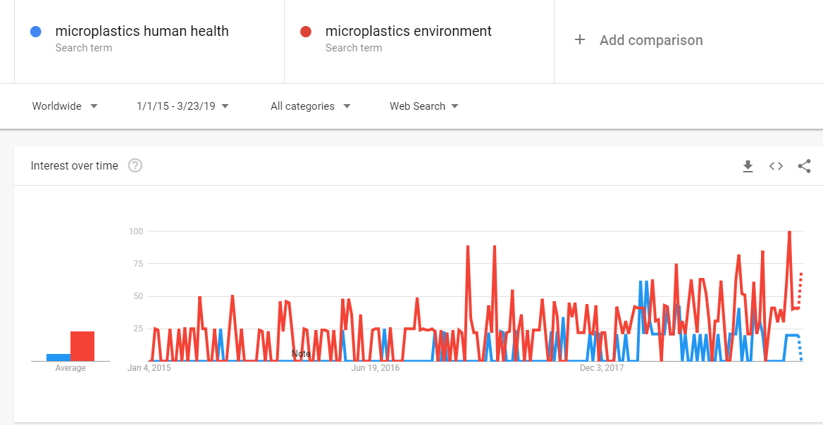
Figure 3. The number of Google searches for ‘microplastics human health’ and ‘microplastics environment’ since 2015 (Data source: Google Trends).
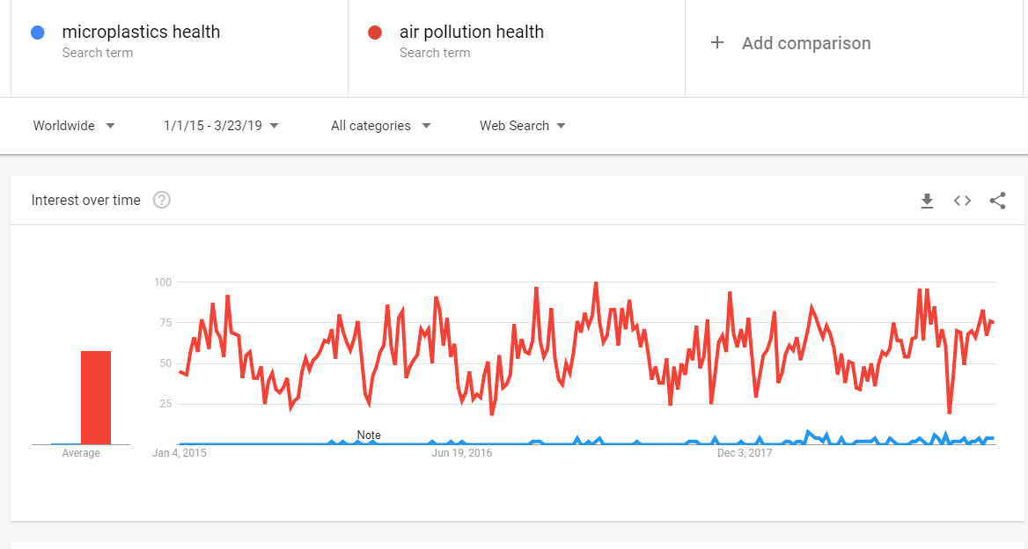
Figure 4. The number of Google searches for ‘microplastics health’ and ‘air pollution health’ since 2015 (Data source: Google Trends).

In order to gain insight into how microplastics are regarded, I sent out a survey to members of my department at the University of Birmingham and to the general public (see appendix A). I did this through use of email and Facebook sharing and received 252 responses. The survey asked how well the respondents understood microplastics as an environmental and as a health issue, whether they had heard of microplastics before and if they had, how they had heard about them. The results showed that most participants did not feel they understood microplastics as a health concern, even if they had an idea that they posed an environmental threat. Despite their presence in the public sphere and environment (Forter, 2016; House of Commons, 2016 Knapton, 2018), almost 10% of respondents had not heard of microplastics before, indicating that microplastics and human health is a topic worthy of improved public communication and a valid case study for investigating communication.
Results of Survey:
The survey reported that the majority of participants (53.5%) did not feel they understood microplastics as a health concern (scored 4 or less on a 1-10 scale where 10 = ‘I understand microplastics in relation to human health very well and 1= ‘I know nothing about it’) with only 24.7% reporting that they understood microplastics as a health concern well (scored 7 or more). My sample was largely aware of microplastics as a threat to the environment as just over half (51.2%) answered 7 and above to ‘I understand microplastics as an environmental concern’ however a proportion of participants (9.9%) reported that they had not ever heard of microplastics before the survey (Figure 6).
23.8% of people reported that they felt microplastics as a threat to human health to be a ‘very concerning’ issue and 54% answered yes to the question: ‘Do you believe that ingesting micro plastics (plastic fragments/fibers smaller than 5 mm) is a risk to human health?’ indicating that a proportion of the population considered the topic to be very concerning and that most suspected that could be harmful. 52.8% of people asked heard about the microplastics via the news, whereas 12.7% heard about them via social media and 9.1% from documentaries. 4.8% (12 participants) heard about microplastics from scientific sources including reports and lectures. For full results and questions see Appendix A.
Have you heard about microplastics before this survey?
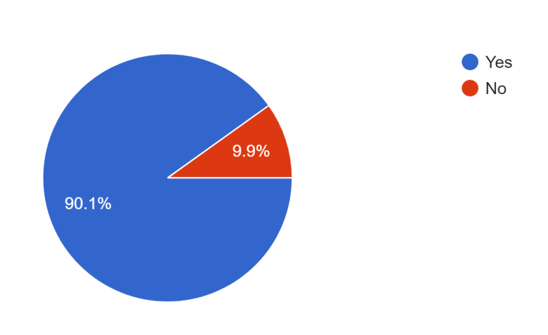
Figure 6. Yes and no responses to question ‘Have you heard about microplastics before this survey?’ as a percentage.

How well do you feel you understand micro-plastics as a human health concern? 1=I don’t know anything about it 10= I understand micro-plastics in relation to human health very well
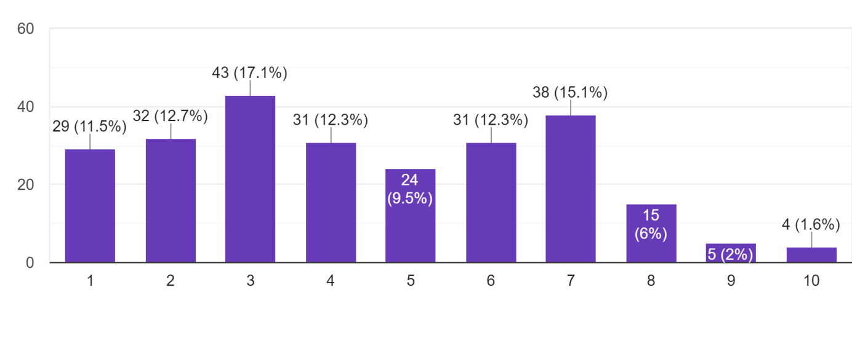
Figure 7. Responses to question: How well do you feel you understand micro-plastics as a human health concern? 1=I don’t know anything about it 10= I understand micro-plastics in relation to human health very well.
The main limitation of this survey’s data was the voluntary nature of the sample which was likely to reflect the views of those who were perhaps more interested in the topic (due to ‘self-selection bias's) despite the introduction to the survey making clear that there was no prior knowledge required in order to fill it out (Jabeen et al, 2018). The sample was collected via connected social media and the department’s email systems, meaning that only those in connection or indirect connection with me (largely English and a few English-speaking Europeans) would have answered it, which fails to reflect a wider global society. However, the large sample size is suggestive that the data I collected provided reliable insight into an educated UK population, (as 90.9% of respondents reported to have had some form of higher education (undergraduate or above). A large number of respondents were within the age category 18-25, meaning that the data obtained may not represent those of the other ages (61.4 % of respondents were 18-25) and I did not ask participants who were below the ages of 10 as I felt it unlikely that I would reach participants of this age via Facebook or email, so the data does not report the understanding of younger children either. The questions were written with unbiased language (provided options for ‘I don’t know’ to prevent forced answers), indicating that the results are likely to be unbiased and true to these populations beliefs. The survey followed ethics process of the Association of Social Anthropologists of the UK and the Commonwealth.
Discussion:
The results of my survey indicate that there is less certainty on the topic of microplastics as a health concern that as there is on microplastics and the environment, but that a large proportion of people were uncertain about microplastics as an environmental concern too. I found that most people heard about microplastics from news coverage, followed by social media and documentaries. There was a slight discrepancy between the percentage of the respondents who said they had never heard of microplastics (9.9%) and those who said that they had heard of microplastics for the first time by filling out the survey (9.1%) suggesting that some answers may have been inconsistent (one would expect these figures to be identical if answered truthfully, because if one has not heard of microplastics before, then the survey would be their first contact by necessity). I deduced that ~9% of the sample were totally new to the topic of microplastics.
The proportion of people who do not know about microplastics is likely to be higher than found in my study due to the highly educated sample being more likely to know about areas of environmentalism and human health than perhaps the average (90.9% of respondents reported to have had higher education of some form) and due to self-selection bias indicating that people may have ignored the survey if they were unfamiliar with the topic (Jabeen et al, 2018). When considering the prevalence of microplastics within the biosphere as well as public media (e.g. mentioned within a TV show that was the most watched BBC program of 2017) (BBC News, 2018) I found the number who had not heard of microplastics intriguing. Nearly a quarter of the sample (23.8%) reported that they felt microplastics as a threat to human health to be a ‘very concerning’ issue, confirming that microplastics and human health is an area worth communicating about.
Study
Introduction/set up:
Following the results of my primary and secondary data I wanted to investigate whether art would be able to communicate information about microplastics and get a qualitative assessment on the value of art as a method of communication. Assumptions and theories about arts ability to relay information directly have rarely been tested empirically and none exist comparing fine art and posters. I sought to provide academic data to back up the claims made by artists and scientists alike. My survey had shown that microplastics were not a well understood topic, whilst my artistic literature review revealed that visual art has the capacity to communicate, and that its ability to do so was modulated by many factors. Failing to gain permission to carry out detailed scanning of brains and or use eye tracking software (due to lack of resources and GDPR laws, respectively), I discerned that an achievable level of detail about the communicative ability of art in relaying of information could be achieved through a direct comparison test of two modes: painting and poster. If people would vote that a painting communicated more effectively than a poster, it could be discerned that art has abilities to communicate information that directly coding forms of communication lack, potentially opening up areas for further communicative/ outreach inspired research.
I displayed a poster and a painting on the same theme of microplastics and human health within the foyers of 3 buildings within the University of Birmingham: A bioscience building (assumed to be populated largely with scientifically minded staff and students), a social science building (known as the Muirhead building) containing predominantly sociology, English and linguistic students and staff, and the Liberal arts and Natural Sciences hub (a large study room populated by students and staff who engage with a mixture of many disciplines). This would allow me to test the contextual effect on the viewing of artwork as stressed by the information processing model as well as test the communicative abilities of art and scientific poster alike. Based on my review, arts ability to confer ideas was based on a subtle manipulation of the ‘cognitive space’ of the viewer. I was interested to test whether this form of communicating could be compared to that of a more direct ‘encoded’ way of communicating that came with more simplistic use of text.
The study was set up following ethics process of the Association of Social Anthropologists of the UK and the Commonwealth. I presented two pieces on 200cm tall poster boards in the three locations. They were separated by approximately 40 cm and each was labelled either 1 or 2. A sign on the board instructed participants to choose which medium communicated with them most effectively ‘‘Which is more effective at communicating? 1, 2, 0 or /”. The sign also explained that ‘0’ indicated ‘uncertain’ and ‘/’ that neither piece communicated at all. Votes were cast by ripping off the number that delineated the better communicator from a sheet of voting slips. These voting slips were pinned to the board. To vote, one ripped off a slip and placed it in a small box affixed beside the tear off sheet. There were many more print outs available than were used, so selection was never based on availability of votes, and the number of votes already cast could not be seen. I ensured that one option did not appear more popular than another by deliberately ripping off votes and throwing them away when there seemed an uneven spread of votes. Each display remained up for a minimum of 8 hours, with the liberal arts hub data collected over 2 days due to the relatively low foot traffic of this location and lesser constraints on time to use the poster boards. I was present for around 50% of the time the display was up during the Muirhead and Bioscience conditions, encouraging people to take part in person (however, I did not talk to members of the LANS hub due to the slow foot traffic and the chances that I would know the participants, as this is my own university department).
The painting depicted a young man in a kitchen, surrounded by commonplace items such as bananas, plastic cups, washing up liquid, bottles and utilities (see Figure 9). Both painting and poster (Figure 8) used household imagery to relate the issue to the viewers personal life and to ensure the semantics of these images were not influencing choice (Leder & Nadal, 2014). The choice to present the man in a commonplace environment was also based on an emphasis within papers for a ‘balanced’ consideration of the wider use of plastics as key to the issue of microplastics and human health, rather than a focus entirely on microplastics, which has the potential to pull focus ‘away from the root of the problem: The way in which we consume, use and dispose of plastics’ (Rist et al, 2018). It was painted using acrylic and oil paint and all the elements were representative/ easily identifiable. Across the composition, snippets of hand painted text read out pieces of information about microplastics such as ‘microplastics permeate our daily lives’ and ‘Polyethylene low toxicity, 28.9% of overall Plastic demand’. These pieces of text describe the demand and toxicity of the plastics as they were at the time according to the 2017 Plastics Europe data. The text correlated to the placement within the scene, with polypropylene described on the part of the painting which displaying a plastic container for example. The poster described microplastics in relation to human health in a clear layout of text boxes containing information about microplastics, the potential effects of microplastics on human health and images of some of the plastics in highest demand, along with their toxicology. Both pieces were brightly coloured and used geometric shapes.
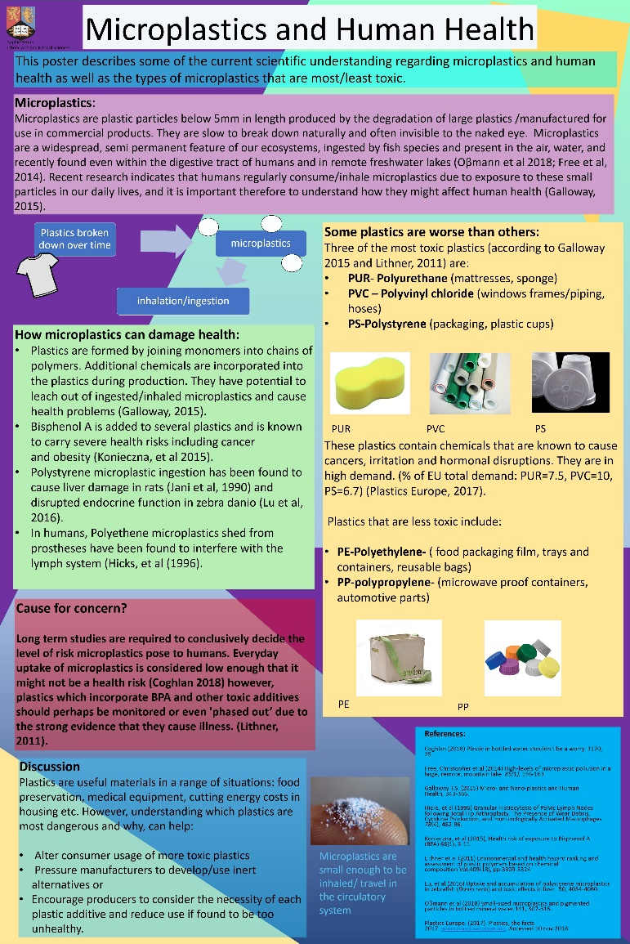
Figure 8. Poster
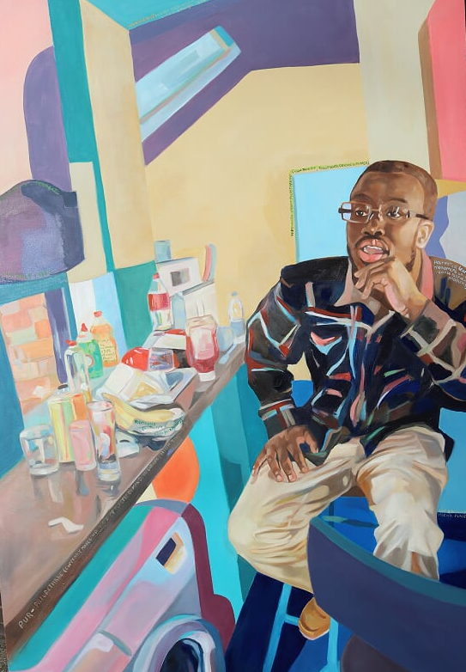
Figure 9. Painting
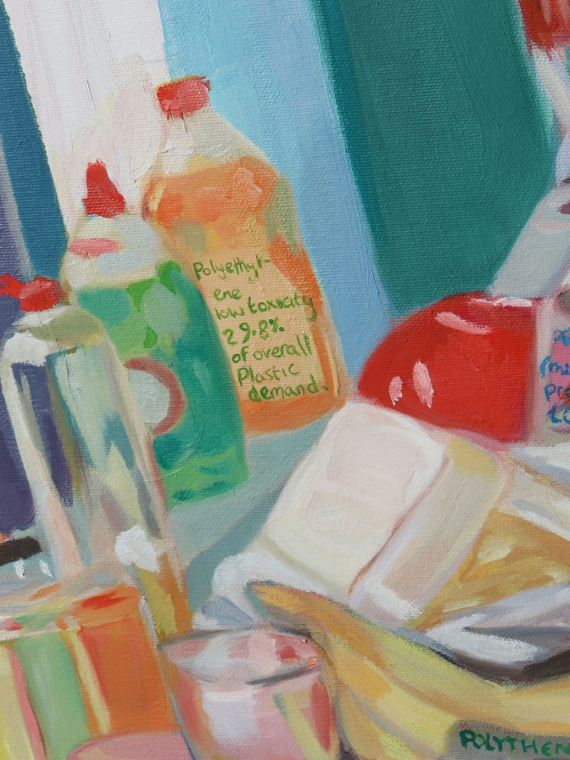
Figure 10. Painting (detail).
Although limited by the availability and willingness of space holders as well as the length of time I was permitted to use the poster boards (maximum one day in the case of Muirhead), using these locations meant that I could get an indication into whether the nature of the educational/research background had an influence on participants preferences for information transmission (for example, whether those within the bioscience building would be more likely to be drawn towards the scientific poster). It also allowed me to collect a more diverse sample of respondents than if I had used just one. I hypothesized that the bioscience participants would favour the poster more than so than participants in the other conditions and predicted that most people would prefer to read a poster.
Controls/Method:
To the best of my ability, extraneous variables and biases were controlled for during the study. Both the painting and the poster incorporated a similar, bright colour scheme so that this would not be an influencer on choice or mood (Vessel et al, 2012). Both contained text as this has been implicated in having an impact on the level of information images are able to confer (in studies involving advertising and art as well as within theories of visual communication) (Bateman, 2014; Jeong, 2008). The most noticeable difference between the poster and the painting, was the size difference. Due to logistical troubles getting a poster printed to the correct size and level of clarity, the poster was 84.1cm x 118.9cm and the painting was 100cm x150cm (39.4 x 59 inches vs 33.1 x 46.8 inches). To compensate for this, it is worth noting that the poster was brighter than the painting (due to the vivacity of the printer ink). The level of complexity of a visual stimulus has been shown to be linked to perceived beauty, but only in very representational, non-artistic images (Nadal et al, 2010) so I concluded that the complexity of the stimuli would be unlikely to have affected preference.
I used the same aspect ratios for both pieces to ensure biases based on shape played no part in voting decision and a traditional form of composition in order to reduce alienation to viewers of the artwork based on its level of abstraction (modern and conceptual art is generally found to be more off putting to non-artists than more representative work) (Gompertz, 2012; Nadal et al 2010). I utilized the golden ratio in order to place the face of the subject in the most aesthetically pleasing position and provide an element of aesthetic beauty (Maor, 2014) and the choice to produce a poster and a painting myself would allow me to compare the two modes of communication without causing any bias based on the artists individual preferences and schema. It was unlikely that many of the participants of my study were skilled visual artists, or experts on microplastics (due to the university having no visual art department and the topic being relatively niche and recent) alleviating bias towards the stimuli due to familiarity (Park et al, 2010).
As my own biases had potential to influence who I spoke to during the study and which piece they chose, I was careful to reveal nothing about the pieces or that they were created by myself. There were at least two votes in the data set from people who know me, with their votes being 0 in one case and 1 (painting) for another but I attempted to ask a diverse set of strangers to vote for the poster or painting during the majority of the study, so that my own social groups would not have influenced the sample set. I did this by selecting random members of the public who happened to stand near the display. I displayed the pieces in public spaces in order to maximize the diversity of my sample, yet due to the nature of the location, the audience would have a higher than average proportion of university attendees and would therefore have been less valid than if it had been displayed in more indiscriminate areas of the public.
Two of the locations (Muirhead and Bioscience building) were busy environments, in which encouraging people to stop and engage with my study would have been tricky if participants had had to spend more than a minute voting, and therefore, the easy tear off votes helped more participants take part. Whilst my methodology limited the detail of my findings (for example I do not know why most participants chose their responses) it meant that I could gather more of it and collect empirical data in addition to noting qualitative verbal feedback and observations.
Results:
I found that of the 109 votes cast, 54.1% voted for the poster and 35.8% of participants favoured the painting. The remaining 10.1% said that they were uncertain (no votes were cast for ‘neither’). This suggests a large proportion of people value the interpretive form of communication (art) more so than the coding form alone. There was no significant difference between selection for poster or painting in the LANS hub or the social sciences (Muirhead) location. However, significantly more votes were cast for the poster than the painting in the bioscience location indicating that art is a better/ worse form of communication for people depending on their professions/with specific interests. When all the data was considered together, the poster was chosen significantly more than the painting (as well as significantly more than the 'uncertain’ option). The LANS location had no significant difference between the poster, painting and ‘uncertain’ vote but the Muirhead and Bioscience locations had significantly fewer votes for uncertain than the painting/poster. I using the chi squared method at p>0.05 reliability for my statistical tests and the data is described in Table 3 and Table 4.

Location | Painting votes | Poster votes | 0 (uncertain) votes | / (neither) votes | Total votes
Muirhead | 23 | 28 | 4 | 0 | 55
Biosciences | 5 | 21 | 1 | 0 | 27
LANS Hub | 11 | 10 | 6 | 0 | 27
Total | 39 | 59 | 11 | 0 | 109

Table 3: Numbers of votes for painting, poster, uncertain and neither in three locations across the university of Birmingham.

 | Observed | Expected | Difference | Difference Sq. | Diff. Sq. / Exp Fr. | Significant diff between poster and painting.
Painting (M) | 23 | 25.5 | -2.5 | 6.25 | 0.25
Poster (M) | 28 | 25.5 | 2.5 | 6.25 | 0.25
Chi value |  |  |  |  | 0.49 | NO  (Chi value is 0.49. p-value is .48384. The result is not significant at p < .05)
Painting (B) | 5 | 13 | -8 | 64 | 4.92
Poster (B) | 21 | 13 | 8 | 64 | 4.92
Chi value |  |  |  |  | 9.845 | YES  (Chi value is 9.846. p-value is .0017. The result is significant at p < .05.)
Painting (L) | 11 | 10.5 | 0.5 | 0.25 | 0.02
Poster (L) | 10 | 10.5 | -0.5 | 0.25 | 0.02
Chi value |  |  |  |  | 0.048 | NO  (Chi value is 0.048. The p-value is .82726. result is not significant at p < .05.)
Painting (total) | 39 | 49 | -10 | 100 | 2.04
Poster (total) | 59 | 49 | 10 | 100 | 2.04
Chi value |  |  |  |  | 4.082 | YES  (Chi value is 4.082. p-value is .04335. The result is significant at p < .05.)

Table 4: Chi squared statistics applied to data for each condition at a p>0.05 level of certainty to test the level of significance between the number of votes for the poster against the painting (M=Muirhead B=Bioscience, L=Lans Hub).
Although I did not formally record data, I had the opportunity to observe people's reactions to the pieces and listen to their opinions, which were often offered without my asking. Some reported that they chose the poster simply because they ‘don’t like art’ and some chose the painting because they found it more appealing to look at (fitting with studies that show art to be considered more beautiful/aesthetic than non-art) (Nadal et al, 2010). Some suggested that if the text of the painting was clearer, they would have chosen the painting as a mode of communication (indicating that the clarity of the painting was an issue rather than the nature of the medium itself) and more than one individual reported that they had liked the painting more, but had to choose the poster because they felt it told them more information, suggesting that the encoding of information was more successful in the poster and of more importance to communication.
A few participants reported that the painting was far more effective than the poster at communicating about microplastics than the poster however, with two stating that it made them think about how many items in our daily life contained plastic in a general sense. This response appeared to be indicate that the painting had induced a shift in perception about the world, a result that no one reported about the poster. One such participant was a self-reported scientist which I found interesting as although my hypothesis that scientists would be more likely to vote in favour of the more empirical method of communication was confirmed statistically, multiple responses to the pieces existed even within the same faculty.
3.Discussion of study
I evaluate my results primarily through the lens of neuroaesthetics and cognitive models of art and communication. Evolutionary biologists might suggest that different ways of communicating having different preferability has an adaptive advantage to a population as a whole (as both the poster and painting were effective to different people, the population as a whole was able to understand it completely and no votes were cast for ‘neither’) (Krause et al, 2010). Miller (1999) might suggest that the selection for the painting would have occurred due to the conscious/unconscious preference for creative/ intelligent sexual partners and therefore proved an affinity for a more artistic stimulus. As the task was not to choose a favourite of the two, rather identify which communicated better, this may not apply however and flaws in this argument regarding male choice in mate selection and the consideration of art as an accidental behaviour as the result of increased cognition, leads me to consider psychological explanations to a greater degree.
External factors to that of my independent variables will be likely to have influenced my findings, including novelty bias, past experiences, preferences and variation in understanding of the semantics of ‘communication’ (Leder et al, 2004). Park et al (2010) found that individuals favour an unusual/unique option in a set with greater frequency than one that is more common. As such, those who chose the painting may have done so simply because it was a more novel option. Some psychologists argue that it is precisely the novelty and distancing from everyday life that gives art its power however, indicating that a novelty bias may not be a confounding factor, rather an intrinsic character of art itself (Pelowski & Akiba, 2011). Indeed, it may even explain the reason art was chosen as the better communicator, as it is this quality, coupled with stylistic choices, that may help a painting’s content remain in the perceivers mind (“the peculiar artificial character of a work of art, underlined by the painter's style, provides the novelty and the distance necessary for it to be efficiently imprinted in the long-term memory”) (Mandelbrojt, 1994). As the poster was chosen more often overall however, it can be assumed that both poster and painting displayed the same level of novelty or that if votes were made based on novelty then this wasn’t a factor large enough to overcome the value of the communication itself.
Further influences on voting behaviour include that the semantics of the word ‘communicate’ (‘which piece 1 or 2 you believe communicates with you most effectively?’) used on the sign beside the painting and poster may have been understood to mean a transmission of an emotive force to some viewers, and a direct ‘message’ to others (Bassett, 1974). Differences in voting may have been founded on diverse understandings of the question therefore, rather than based on the piece's communicative ability. This individual variance may have been evened out by an ‘average’ understanding of the group however, thus negating such issues (Simons, 2004) although this cannot be confirmed. Preference for faces in visual stimuli may also be implicated in people voting in favour of the painting, as it has been found that humans have a heightened neurological affinity for stimuli that looks like a face (Eimer, 2011). Without detailed questioning of all the participants however, this would be difficult to confirm and may be part of the reason why the painting was able to relay information well. Jeong (2008) found that imagery of a more metaphorical nature produced longer lasting memories of the content, explaining why the less literal information presentation (painting), may have communicated more successfully for some people although this does not explain why the overall favourite choice was the poster however (which had no metaphorical imagery). Many participants who voted for the poster gave reasons such as ‘I’m not very arty’ to explain their choice highlighting the importance of prior experiences with art on its ability to communicate and indicating that some are intimidated by art as a medium (Gompertz, 2012).
Despite artworks being generally considered ‘more beautiful’ than non-artworks (Nadal et al, 2010), most participants voted that the poster was more effective at communicating. This suggests that aesthetic beauty is not a deciding factor in whether something is able to communicate about a topic successfully. More than one individual reported that they had liked the painting more, but had chosen the poster because they felt it told them more information, indicating that communicative ability is linked to the amount of information or ‘efficiency’ of the piece rather than its ability to alter a world view (Sperber & Wilson, 1996). This notion is supported by Augustin et al (2008) who demonstrated that stylistic properties of art are secondary in importance to that of the content/theme of a piece during processing in the brain. Conversely however, some voted for the painting purely because they ‘liked it’, suggesting that choices were sometimes made based more on aesthetics than direct communication.
According to Cupchik et al (2009), viewers of the pieces would have experienced differentially active areas of the brain due to the request that they view the piece based on meaning as opposed to aesthetics. The participants in my study were asked to investigate the two pieces pragmatically: (‘which communicates with you most effectively?’). Pragmatic processing of art was shown to engage the right fusiform gyrus, whereas aesthetic processing involved the bilateral insula. Engagement of the right fusiform gyrus may have been implicit in participants understanding the material and therefore led to votes in favour of it (Cupchick et al, 2009). Participants with a natural inclination towards gaining meaning from aesthetic forms (perhaps those studying humanities subjects for example) might have been swayed in favour of the painting due to a heightened ability to process images using the areas linked to aesthetic processing (Cupchick et al, 2009; Leder & Nadal, 2014). The extent of this preference was found to vary depending on the context of the voting (with the science setting lending itself towards less favourability). Various factors including use of faces, metaphor and style could certainly be considered for further research in order to determine the factors important in whether one chooses a painting over a more scientific method of communicating (Leder et al, 2013).
My findings suggest that over a third of those who participated in the study value an inferential form of communication (art) over that of a coding form, but that the overall preference was for the poster. Population preference for art as a communicative medium was 35.8% but my observations revealed that the painting also elicited far stronger reactions in people than the poster and induced at least one full schematic shift about the nature of microplastics, so may more valuable communicative device for certain individuals. My findings provide empirical evidence to support hypotheses that art can act as a form of information coding communication thus supporting information processing approaches to communication as well as the arguments put forth by Sperber and Wilson (1996). Further study might benefit from questioning the reasons for the choices made by each participant in order to discern better what caused each method to communicate most efficiently.
4. Conclusion
In this dissertation I explored art as a means of communicating about microplastics. Through the collection of primary data, I discovered that art is method of communication with the capacity to encode specific ideas (in this case about microplastic use and human health) that is preferable for a significant proportion, to that of a poster. I provide quantitative evidence to support assumptions that art can communicate effectively as well as some qualitative information they may help ask the right questions about why this might be. My findings support notions that context and individual differences are likely to play a part in the process of artistic evaluation and judgement, as different locations favoured the poster and painting differently (Chatterjee, 2011; Leder et al, 2013).
In addition to findings about the nature of artistic communication, I have produced primary data concerning public knowledge on microplastics which detail the nature of public understandings towards microplastics as a health risk. These findings suggest a need for improved education about microplastics and an uncertainty surrounding the topic of microplastics and human health. I have also provided secondary data through my literature review about the nature of microplastics and human health, concluding that microplastic consumption has risks associated with chemical leaching and uptake across organ systems, but that the topic has as yet to be conclusively explored in human studies (Galloway, 2015).
Understanding what a painting provides in terms of effective communication that a poster does not, could be key to the development of improving communicative devises as well as understanding how art functions and justifying its funding. Even if through novelty value, conveying information via painting can be seen to have great potential for scientific public engagement. Further studies might investigate what aspects of art enable it to communicate successfully and investigate further the significance of these mechanisms in communication.

- Ahmet, T K; Meral, Y & Senem CB (2018) Ubiquitous exposure to microfiber pollution in the air The European Physical Journal Plus, 133(11),1-9.
- Anonymous (1994) What is communication? The International Journal of Bank Marketing, 12(1), 19.
- Appenzeller, T (1998) Art: Evolution or Revolution? Science, 282(5393), 1451-1454.
- Augustin, M D; Leder, H; Hutzler, F & Carbon, C-C (2008) Style follows content: On the microgenesis of art perception Acta Psychologica, 128(1), 127-138.
- Barter, N B; Tregidga, H (2014) Storytelling Beyond the Academic Article: Using Fiction, Art and Literary Techniques to Communicate. Journal of Corporate Citizenship, 54, 5-11
- Bassett, G A. (1974). What is communication and how can I do it better? Management Review, 63 (2), 25-33.
- Bateman. (2014). Text and image: a critical introduction to the visual-verbal divide Abingdon, Oxon; New York, New York: Routledge.
- BBC News. (2018). Blue Planet II tops 2017 TV ratings. Retrieved from: https://www.bbc.co.uk/news/entertainment-arts-42641146.
- Beer, S., Garm, A., Huwer, B., Dierking, J & Nielsen, T.G. (2017). No increase in marine microplastic concentration over the last three decades-A case study from the Baltic Sea. Science of the Total Environment 621, 1272-1279.
- Berger, J (1972) Ways of seeing / John Berger. London: Penguin. 1-30.
- Blake, M. (2014). The Scary New Evidence on BPA-free plastics And the Big Tobacco-style campaign to bury it Mother Jones. Available at: https://www.motherjones.com/environment/2014/03/tritan-certichem-eastman-bpa-free-plastic-safe/.
- Brown, S. (2019). A Unifying Model of the Arts: The Narration/Coordination Model Empirical Studies of the Arts. https://doi.org/10.1177/0276237419828213
- Bundgaard, P F. (2015). “Feeling, meaning, and intentionality—a critique of the neuroaesthetics of beauty,” Phenomenology and the Cognitive Sciences, 14 (4), 781–801.
- Carington, D (2019, Mar 7) “Microplastic pollution revealed ‘absolutely everywhere’ by new research” The Guardian. Retrieved from: https://www.theguardian.com/environment/2019/mar/07/microplastic-pollution-revealed-absolutely-everywhere-by-new-research
- Catarino, A., Macchia, V., Sanderson, W G., Thompson, R C. & Henry, T B. (2018). Low levels of microplastics (MP) in wild mussels indicate that MP ingestion by humans is minimal compared to exposure via household fibres fallout during a meal. Environmental Pollution 237, 675-685.
- Chatterjee, A (2011) Neuroaesthetics: A Coming of Age Story Journal of Cognitive Neuroscience, 23(1), 53.
- Chatterjee, A ; Vartanian, O (2014) Neuroaesthetics Trends in Cognitive Sciences, 18(7), 370-375.
- Chatterjee, A. (2004). Prospects for a cognitive neuroscience of visual aesthetics. Bull. Psychol. Art 4, 55–60.
- Clarke, Steven. (2018, Oct 23). Plastic particles found in human digestive systems University Wire, 201.
- Coghlan, A (2018) Plastic in bottled water shouldn't be a worry. New Scientist 3170, 25.
- Collingwood, R G (1938) The Principles of Art. Clarendon Press, Oxford 336.
- Cooper, J E., Kendig, E L, & Belcher, S M. (2011). Assessment of bisphenol A released from reusable plastic, aluminium and stainless-steel water bottles. Chemosphere, 85(6), 943-94.
- Critchley H.D., Wiens S., Rotshtein P., Ohman A., & Dolan R.J. (2004). Neural systems supporting interoceptive awareness Nature Neuroscience, 7, 189-195.
- Crocchiola, D (2014) Art as an Indicator of Male Fitness: Does Prenatal Testosterone Influence Artistic Ability? Evolutionary Psychology, 12(3).
- Cupchik, G. C., Vartanian, O., Crawley, A., & Mikulis, D. J. (2009). Viewing artworks: Contributions of cognitive control and perceptual facilitation to aesthetic experience. Brain and Cognition, 70, 84–91. doi: 10.1016/j.bandc.2009.01.003.
- Curtis, D. J., N. Reid, & G. Ballard. (2012). Communicating ecology through art: what scientists think. Ecology and Society 17(2): 3. http://dx.doi.org/10.5751/ES-04670-170203.
- Cuypers, K ; Krokstad, S ; Lingaas H, Turid ; Skjei K, M ; Bygren, LO & Holmen, J (2012) Patterns of receptive and creative cultural activities and their association with perceived health, anxiety, depression and satisfaction with life among adults: the HUNT study, Norway Journal of Epidemiology and Community Health, 66(8), 698.
- Da Costa, B. (2008). Tactical biopolitics: art, activism and technoscience / edited by Beatriz da Costa and Kavita Philip; with a foreword by Joseph Dumit. Cambridge, Mass; London: MIT.
- Davies, S. (2012). The artful species. Oxford, UK : Oxford University Press.
- Ding, J., Zhang, S., Razanajatovo, R M., Zou, H, & Zhu, W. (2018). Accumulation, tissue distribution, and biochemical effects of polystyrene microplastics in the freshwater fish red tilapia (Oreochromis niloticus). Environmental Pollution 238, 1-10.
- Eimer, M. (2011). The Face-Sensitive N170 component of the event-related brain potential Oxford Handbook of Face Perception. 430 DOI: 10.1093/oxfordhb/9780199559053.013.0017.
- European Food Safety Authority (2018). EFSA panel renewal 2018: experts wanted for contaminant panel. Retrieved from: http://www.efsa.europa.eu/en/press/news/170511-2.
- Finnegan, R (2002) Communicating: the Multiple Modes of Human Interconnection Taylor & Francis Group 1-30.
- Forster, K. (2016, May 21). Microplastics in the sea a growing threat to human health, United Nations warns. The Independent. Retrieved from https://www.independent.co.uk/environment/microplastics-microbeads-ocean-sea-serious-health-risks-united-nations-warns-a7041036.html.
- Free, C M., Jensen, O.P., Mason, S.A., Eriksen, M., Williamson, N.J. & Boldgiv, B. (2014). High-levels of microplastic pollution in a large, remote, mountain lake. Marine Pollution Bulletin 85(1), 156-163.
- Galloway T.S. (2015). Micro- and Nano-plastics and Human Health. In: Bergmann M., Gutow L., Klages M. (eds). Marine Anthropogenic Litter, 343-366.
- GESAMP. (2015). Sources, fate and effects of microplastics in the marine environment: A global assessment [online] International Maritime Organization, 4. Available at: http://ec.europa.eu/environment/marine/good-environmental-status/descriptor-10/pdf/GESAMP_microplastics%20full%20study.pdf [Accessed 4 Feb. 2019].
- Gompertz, W (2012) What are you looking at? Penguin group USA, 10.
- Google trends (2019) Accessed via: https://trends.google.com/trends/?geo=US.
- Guerilla Girls (2011) Projects. Accessed via: https://www.guerrillagirls.com/projects.
- Hamilton, J (2015, Feb 16) Beyond BPA: Court Battle Reveals A Shift in Debate Over Plastic Safety NPR Retrieved from: https://www.npr.org/sections/health-shots/2015/02/16/385747786/beyond-bpa-court-battle-reveals-a-shift-in-debate-over-plastic-safety?utm_source=facebook.com&utm_medium=social&utm_campaign=nprpresents&utm_term=aboutnpr&utm_content=20150216&t=1551630285328.
- Harper, (2016). David Walsh of Mona: on art, sex and why (gallery) size matters The Guardian available at: https://www.theguardian.com/artanddesign/2016/nov/09/on-the-origin-of-art-david-walsh-launches-monas-most-ambitious-exhibition-yet.
- Harvey, F & Watts, J (2018) Micro plastics found in human stools for the first time The Guardian Retrieved from: https://www.theguardian.com/environment/2018/oct/22/microplastics-found-in-human-stools-for-the-first-time.
- Hicks, G., David,. Judkins, R., Alexander,. Sickel, Z., Joshua ; Rosier, N., Randy ; Puzas, E, J. ; Oʼkeefe, J., & Regis. (1996). Granular Histiocytosis of Pelvic Lymph Nodes following Total Hip Arthroplasty. The Presence of Wear Debris, Cytokine Production, and Immunologically Activated Macrophages The Journal of Bone & Joint Surgery 78(4), 482-96.
- Hoet, P., Brüske-Hohlfeld, I, & Salata, O V. (2004). Nanoparticles – known and unknown health risks Journal of Nanobiotechnology, 2(1), 12. 10.1186/1477-3155-2-12.
- Horton, A., Walton, A., Spurgeon, D J., Lahive, E & Svendsen, C. (2017). Microplastics in freshwater and terrestrial environments: Evaluating the current understanding to identify the knowledge gaps and future research priorities. Science of the Total Environment. 586, 127-141.
- Ingold, T. (2018). From science to art and back again: the pendulum of an anthropologist, Interdisciplinary Science Reviews, 43:3-4, 213-227, DOI: 10.1080/03080188.2018.1524234.
- Jabeen K., Su, L., Li, J., Yang, D., Tong, C., Mu, J & Shi, H. (2017) Microplastics and Mesoplastics in fish from coastal and fresh waters of China. Environmental Pollution 221, 141-149.
- Jabeen, F., Olaru, D & Smith, B(2018) Combining samples to offset nonresponse and respondent biases Case Studies on Transport Policy,.6(2), 190-199.
- Jacobsen, T (2006) Bridging the Arts and Sciences: A Framework for the Psychology of Aesthetics Leonardo,.39(2), 155-162.
- Jani et al (1989) The uptake and translocation of latex nanospheres and microspheres after oral administration to rats. Journal of Pharmacy and Pharmacology 41(12), 809-12.
- Jani P, Halbert GW, Langridge J, Florence AT. (1990). Nanoparticle uptake by the rat gastrointestinal mucosa: quantitation and particle size dependency. Journal of Pharmacy Pharmacology 42(12), 821-6.
- Jani, P.U., Mccarthy, D.E, & Florence, A.T. (1992). Nanosphere and microsphere uptake via Peyer's patches: observation of the rate of uptake in the rat after a single oral dose International Journal of Pharmaceutics, 1992, 86(2), 239-246.
- Jeong, S, (2008). Visual Metaphor in Advertising: Is the Persuasive Effect Attributable to Visual Argumentation or Metaphorical Rhetoric? Journal of Marketing Communications, 14 (1), 59-74.
- Jonze, T. (2018, nov 11). Icebergs ahead! Olafur Eliasson brings the frozen fjord to Britain The Guardian. Retrieved from: https://www.theguardian.com/artanddesign/2018/dec/11/icebergs-ahead-olafur-eliasson-brings-the-frozen-fjord-to-britain-ice-watch-london-climate-change.
- Kant, I (1978) The critique of judgment (J.C. Meredith, Tans.) Oxford University Press, Oxford, England (Original work published in 1790).
- Kéri, S (2009) Genes for psychosis and creativity: a promoter polymorphism of the neuregulin 1 gene is related to creativity in people with high intellectual achievement. Psychological Science (0956-7976) 20 (9), 1070-107.
- Kerr N.L. & Tindale R.S. (2004). Group performance and decision making Annu. Rev. Psychol, 55, 623-655.
- Kirstein, I V., Kirmizi, S., Wichels, A., Garin-Fernandez, A., Erler, R., Löder, M & Gerdts, G. (2016). Dangerous hitchhikers? Evidence for potentially pathogenic Vibrio spp. on microplastic particles. Marine Environmental Research 120, 1-8. 10.1016/j.marenvres.2016.07.004.
- Knapton. (2018). Microplastics have been found in humans for the first time. It’s a worry The Sydney Morning Herald. https://www.smh.com.au/world/europe/microplastics-have-been-found-in-humans-for-the-first-time-it-s-a-worry-20181023-p50bbd.html.
- Konieczna, A., Rutkowska, A, & Rachon, D. (2015). Health risk of exposure to Bisphenol A (BPA). Annales of National Institute of Hygiene, 66(1), 5-11.
- Krause J., Ruxton G.D., & Krause S. (2010). Swarm intelligence in animals and humans Trends in Ecology & Evolution, 25, 28-34.
- Lasher, M. D., Carroll, J. M., and Bever, T. G. (1983). The cognitive basis of aesthetic experience. Leonardo 16, 196–199. doi: 10.2307/1574913.
- Leder, H (2013) Next Steps in Neuroaesthetics: Which Processes and Processing Stages to Study? Psychology of Aesthetics, Creativity, and the Arts, 7(1), 27-37.
- Leder, H, & Nadal, M. (2014). Ten years of a model of aesthetic appreciation and aesthetic judgments: the aesthetic episode – developments and challenges in empirical aesthetics British Journal of Psychology,105(4), 443-464.
- Leder, H; Belke, B ; Oeberst, A & Augustin, D. (2004). A model of aesthetic appreciation and aesthetic judgments British Journal of Psychology, 95(4), 489-508.
- Lee, D (2013) “Anybody Can Do It”: Aesthetic Empowerment, Urban Citizenship, and the Naturalization of Indonesian Graffiti and Street Art First retrieved from: https://doi.org/10.1111/ciso.12024.
- Lewis, P. (1995). Art, the community's medicine British Journal of Aesthetics 35(3), 205-216.
- Li, X; Chen, L ; Mei, Q; Dong, B ; Dai, X ; Ding, G & Zeng, E Y. (2018). Micro plastics in sewage sludge from the wastewater treatment plants in China. Water Research, 142, 75-85.
- Liebezeit, E & Liebezeit, G. (2014). Synthetic particles as contaminants in German beers. Food Additives & Contaminants: Part A. 31, 1574-1578 10.1080/19440049.2014.945099.
- Lithner, D., Larsson, Å & Dave, G. (2011). Environmental and health hazard ranking, and assessment of plastic polymers based on chemical composition. Science of the Total Environment, 409(18), 3309-3324.
- Liu, J., Lughofer, E & Zeng, X. (2017). Toward Model Building for Visual Aesthetic Perception. Computational Intelligence and Neuroscience 2017, 1292801. doi:http://dx.doi.org/10.1155/2017/1292801.
- Lu, L., Wan, Z ., Luo, T., Fu, Z, & Jin, Y(2018) Polystyrene microplastics induce gut microbiota dysbiosis and hepatic lipid metabolism disorder in mice Sci. Total Environ., 631–632, 449-458.
- Lu, Y., Zhang, Y., Deng, Y., Jiang, W., Zhao, Y., Geng, J., Ding, L & Ren, H. (2016). Uptake and accumulation of polystyrene microplastics in zebrafish (Danio rerio) and toxic effects in liver. Environment Science Technology 50, 4054-4060.
- Magritte, R. (1929). The treachery of images (This is Not a Pipe) (La trahison des images [Ceci n'est pas une pipe]) LACMA available at: https://collections.lacma.org/node/239578.
- Mandelbrojt, J. (1994). Art and Science Similarities, Differences and Interactions: Special Issue. Leonardo, 27 (3), 189-201.
- Mantovani, D & Tazima, D I. (2016). Visual Art and Regulatory Fit Messages on Consumer Evalutaions RAE: Revista de Administração de Empresas, 56 (2), 152-166
- Maor, E & Jost, E. (2014). Beautiful geometry Princeton: Princeton University Press, 1-10.
- Mcleish T & Poon W. (2001). How many cultures? ‘Real presences’ and the healing of the academy, Interdisciplinary Science Reviews, 26:3, 167-172, DOI: 10.1179/030801801679421.
- Millar, I (2011) How women changed the (art) world. Art Newspaper, 20(220), 47.
- Miller, G. F. (1999). Sexual selection for cultural displays. In R. Dunbar, C. Knight, & C. Power (Eds.), The evolution of culture. Edinburgh, Scotland: Edinburgh U. Press, 71-91.
- Morris, D (2013) The Artistic Ape: Three Million Years of Art Red Lemon Press (2013) ISBN 10: 1783420022, 1-30.
- Nadal, M ; Munar, E ; Marty, G & Cela-Conde, C. J. (2010). Visual Complexity and Beauty Appreciation: Explaining the Divergence of Results Empirical Studies of the Arts, 28(2), 173-191.
- Oβmann B E., Sarau, G., Holtmannspötter, H., Pischetsrieder, M., Christiansen, S H & Dicke, W. (2018). Small-sized microplastics and pigmented particles in bottled mineral water. Water Research, 141, 307-316.
- Park J., Shimojo E. & Shimojo S. (2010). Roles of familiarity and novelty in visual preference judgments are segregated across object categories Proceedings of the National Academy of Sciences, 107, 14552-14555.
- Parliament UK. (2016). Environmental impact of microplastics (Report no. 4). London, UK authority of the House of Commons. Retrieved from: https://publications.parliament.uk/pa/cm201617/cmselect/cmenvaud/179/17905.htm#_idTextAnchor011.
- Pater, W. (1893). The Renaissance: studies in art and poetry 1839-1894. London; New York Macmillan, 4th ed, 250.
- Pelowski, M., & Akiba, F. (2011). A model of art perception, evaluation and emotion in transformative aesthetic experience. New Ideas Psychol. 29, 80–97. doi: 10.1016/j.newideapsych.2010.04.001.
- Pelowski M; Markey P S; Lauring J O & Leder H. (2016). Visualizing the Impact of Art: An Update and Comparison of Current Psychological Models of Art Experience. Frontiers of Human Neuroscience.
- Pico, Y, Alfarhan, A & Barcelo, D. (2018). Nano And Microplastic Analysis: Focus on Remediation Technologies and Occurrence in Freshwater Ecosystems, TrAC Trends in Analytical Chemistry. 14(1) 1-17. 10.1016/j.trac.2018.08.022.
- Pivokonsky M., Cermakova, L., Novotna, K., Peer, P., Cajthaml, T & Janda, V. (2018). Occurrence of microplastics in raw and treated drinking water. Science of the Total Environment, 643, 1644-1651.
- Plastics Europe. (2017). Plastics, the facts 2017. Retrieved from: www.plasticseurope.org.
- Plastics Europe. (2018). Plastics, the facts 2018. Retrieved from: https://www.plasticseurope.org/application/files/6315/4510/9658/Plastics_the_facts_2018_AF_web.pdf.
- Plastics International. (2018). Chemical resistance guide. Retrieved from: http://www.plasticsintl.com/plastics_chemical_resistence_chart.html.
- Prata, J. (2018). Airborne microplastics: Consequences to human health? Environmental Pollution 234, 115-126.
- Rees, J. (2013, Sept 29). The naked truth about creativity Sunday Times, 6-7. Retrieved from https://search.proquest.com/docview/1462181343?accountid=8630
- Ribeiro, F., O'Brien, J W., Galloway, T & Thomas, KV. (2019). Accumulation and fate of nano- and micro-plastics and associated contaminants in organisms Trends in Analytical Chemistry, 111, 139-147.
- Rist, S., Carney Almroth, B., Hartmann, N B & Karlsson, T M. (2018). A critical perspective on early communications concerning human health aspects of microplastics. Science of The Total Environment 626, 720-726.
- Ritson, M & Elliot, R. (1999). The social uses of advertising: An ethnographic study of adolescent advertising audiences. Journal of Consumer Research, 26(3): 260–77.
- Rosch, E. (1975). Cognitive Representations of Semantic Categories, Journal of Experimental Psychology: General 104, No. 3, 192-233.
- Rutten, K; Beveren, LV ; Roets, G. (2018). The New Forest: The Relationship between Social Work and Socially Engaged Art Practice Revisited. British Journal of Social Work, 48 (6), 1700-1718.
- Sanganyado, E., Rajput, I R, & Liu, W. (2018). Bioaccumulation of organic pollutants in Indo-Pacific humpback dolphin: A review on current knowledge and future prospects. Environmental Pollution, 237, 111-126.
- Shafei A., Matbouly, M., Mostafa, E., Sannat, S., Abdelrahman, M., Lewis, B., Muhammad, B., Mohamed, S & Mostafa, R. (2018). Stop eating plastic, molecular signaling of bisphenol A in breast cancer Environmental Science and Pollution Research, 25(24), 23624-23630.
- Shannon, C. & Weaver, W. (1949). The mathematical theory of communication. University of Illinois Press, Urbana, IL., 7-70.
- Simons, A.M. (2004). Many wrongs: The advantage of group navigation. Trends in Ecology and Evolution. 19: 453.
- Smith, M. (2018, May 21-22). YouGov finds overwhelming support for banning ‘Problem Plastics’. YouGov. Retrieved from: https://yougov.co.uk/news/2018/05/29/yougov-finds-overwhelming-support-banning-problem-/.
- Sperber, D & Wilson, D. (1996). Relevance: communication and cognition Oxford : Blackwell, (2)164 accessed via: https://monoskop.org/images/e/e6/Sperber_Dan_Wilson_Deirdre_Relevance_Communica_and_Cognition_2nd_edition_1996.pdf.
- Stevenson-Taylor, A & Mansell, W. (2012). Exploring the Role of Art-Making in Recovery, Change, and Self-Understanding-An Interpretative Phenomenological Analysis of Interviews with Everyday Creative People International Journal of Psychological Studies, 4 3.
- Summers, G F and Hammonds, A D. (1969). Toward a Paradigm for Respondent Bias in Survey Research. Sociological Quarterly, 10 (1), 113-122.
- Tate. (2018). Artist Olafur Eliasson and geologist Minik Rosing have installed Ice Watch, a group of twenty-four blocks of ice, in front of Tate Modern. Retrieved from: https://www.tate.org.uk/whats-on/tate-modern/exhibition/olafur-eliasson-and-minik-rosing-ice-watch.
- Thanos, C. G ; Yip, K.P & Mathiowitz, E. (2004). Intestinal Uptake of Polymer Microspheres in the Rabbit Studied with Confocal Microscopy Journal of Bioactive and Compatible Polymers, 19(4), 247-266.
- The Guardian. (2016, Nov 14). UK to investigate human health impact of microplastics. Retrieved from: https://www.theguardian.com/environment/2016/nov/14/uk-to-investigate-human-health-impact-of-microplastics.
- Tolstoy, L .(1899). What Is Art? translation by Alymer Maude (1899), 6-7.
- Tschacher, W., Greenwood, S., Kirchberg, V., Wintzerith, S., van den Berg, K., and Tröndle, M. (2012). Physiological correlates of aesthetic perception of artworks in a museum. Psychol. Aesthet. Creat. Arts 6, 96–103. doi: 10.1037/a0023845.
- U.S Food and drug administration. (2018). Bisphenol A (BPA): Use in food contact application. Retrieved from: https://www.fda.gov/Food/IngredientsPackagingLabeling/FoodAdditivesIngredients/ucm064437.htm.
- Van Cauwenberghe, L & Janssen, C. (2014). Microplastics in bivalves cultured for human consumption. Environmental Pollution, 193, 65-71.
- Vessel, E., Starr, G, & Rubin, N. (2012). The brain on art: intense aesthetic experience activates the default mode network Frontiers in Human Neuroscience, 2012.
- Volkheimer, G. (1975). Hematogenous dissemination of ingested polyvinyl chloride particles Annals of the New York Academy of Sciences, 246, 164-71.
- Volkheimer, G. (1977). Passage of particles through the wall of the gastrointenstinal tract. Environmental Health Perspectives, 9, 215–225.
- Walsh, J., Barnes, J D., Cameron J D., Goldfield G., Chaput, J, & Gunnell, K E . (2018). Associations between 24-hour movement behaviours and global cognition in US children: a cross-sectional observational study. The Lancet child and adolescent health 2 (11) 783-791. DOI: https://doi.org/10.1016/S2352-4642(18)30278-5.
- Wieczorek A M ; Morrison, L ; Croot, P L ; Allcock, A L ; MacLoughlin, E ; Savard, O ; Brownlow, H & Doyle, T K. (2018). Frequency of microplastics in mesopelagic fishes from the Northwest Atlantic; Frontiers in Marine Science, 5.
- Woolf, V (1929). A room of one's own; Three guineas, Hogarth Press.
- Wright, T. (2011), ‘Press photography and visual rhetoric’, in E. Margolis and L. Pauwels (eds.) The Sage Handbook of Visual Research Methods (London: Sage).
- Youdell, D. (2015). Assemblage Theory and Education Policy Sociology. In K. Gulson, A. Metcalfe, & M. Clarke (Eds.).
- Youdell, D. (2017). Bioscience and the sociology of education: the case for biosocial education. British Journal of Sociology of Education, 38(8), 1273-1287. Available at: https://doi.org/10.1080/01425692.2016.1272406.
- Zahavi, A. (1978). Decorative patterns and the evolution of art. New Scientist, 80, 182 – 184.
- Zeki, S., & Nash, J. (1999). Inner Vision: An Exploration of Art and the Brain, Oxford: Oxford university press, 415.

Appendix A
Public opinion survey microplastics and human health:
Survey introduction:

Micro plastics are small fragments of plastic that are commonly defined as being below 5 mm in size. They are produced for commercial purposes (eg within certain facial scrubs) and as the result of breakdown of larger plastics over time.

Please fill out the below questionnaire to help inform my dissertation project! There are no right or wrong answers and it doesn't matter if you know absolutely nothing about micro-plastics.
Try to be as honest in your responses as possible as this is most useful to my study.

It will take just a couple minutes and will influence both my independent research and artistic practice!

Thank you so much!
If you have any questions/feedback, feel free to email me at sxp509@student.bham.ac.uk
What is your age?

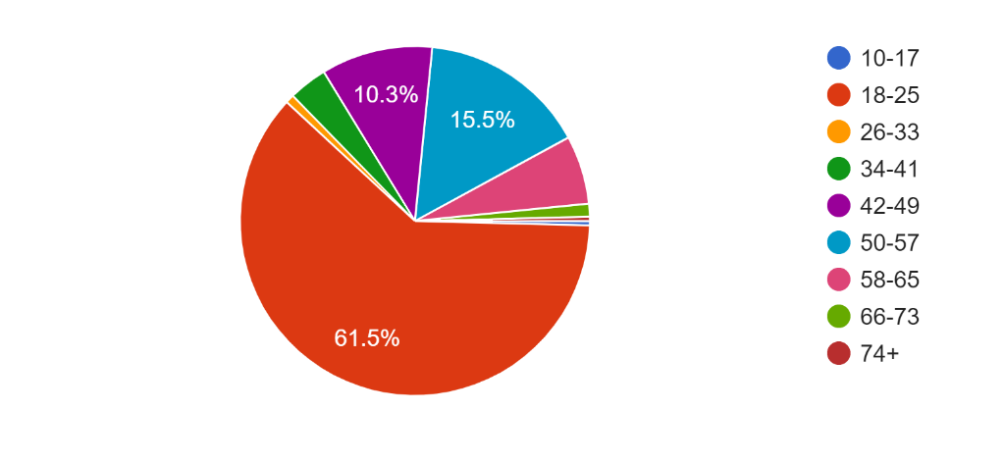
What level of Education did you last receive/are you currently taking? (undergraduate degree/secondary school/masters etc).

Short answer questions were recorded, responses were individual, 90.9% had attended higher education (undergraduate degree or above). Total responses are given:
Undergraduate degree
Undergraduate
Undergraduate
undergraduate degree
Masters
Undergraduate degree
Undergraduate Degree
Degree
Undergrad
undergraduate
masters
Master
MA
BA
undergrad
undergraduate
Undergrad degree
Masters
A Level
Secondary
degree
Bachelors
undergrad degree
Masters degree
Secondary school
Master
currently undergraduate
I have a bachelor's (undergrad)
PhD
A levels
UNDERGRADUATE
undergrad 3rd year
Currently undertaking undergraduate degree
Undergraduate Degree
Diploma of Higher Education
Post Grad diploma
Nurse training
Diploma
High School
Diploma in Physiotherapy
Undergradute degree
A levels.
Undergraduate Degree (2.1 BA)
Hnd
NVQ
BSc, PGDipEd
currently an undergraduate student
PhD
Dip M
HNC
Sixth Form
Doctorate (PhD)
Undergraduate MBChB
A Levels
BA
Post graduate accountancy qualification
PG professional qualifications
Undergaduate degree
Masters in computer science
University teachers training
Current Undergraduate
Postgrad vocational
Secondary School
D.Phil (doctorate)
High school
2nd year undergrad
Master's
College diploma
Bachelor
doing a phd
HNC Business Studies
Postgraduate diploma
Bachelor's degree
Postgraduate
College
u. degree
Bachelor Degree
Doctorate
Post Graduate
Masters (MS in management info systems)
Master’s degree
A levels, currently studying undergraduate degree
Teachers college
Master of Architecture
Undergraduate integrated Masters
Last: NVQ (vocational). None currently undertaken.
O levels
BEng
A-leveld
current undergrad
Abitur
Master business
2 semesters of university
Postgraduate Certificate in Education
Secondary school
A level
A2 level
Bachelors degree (1st)

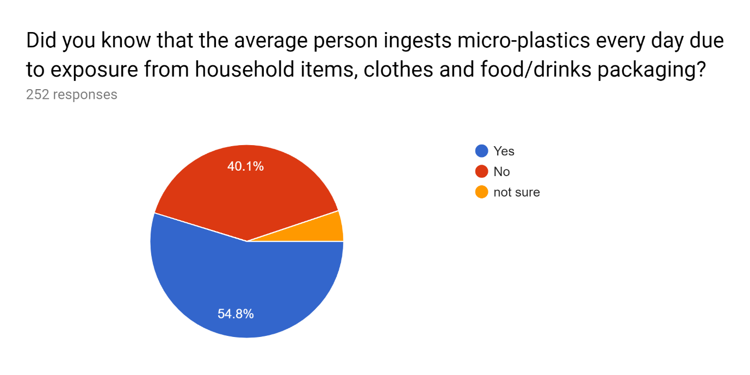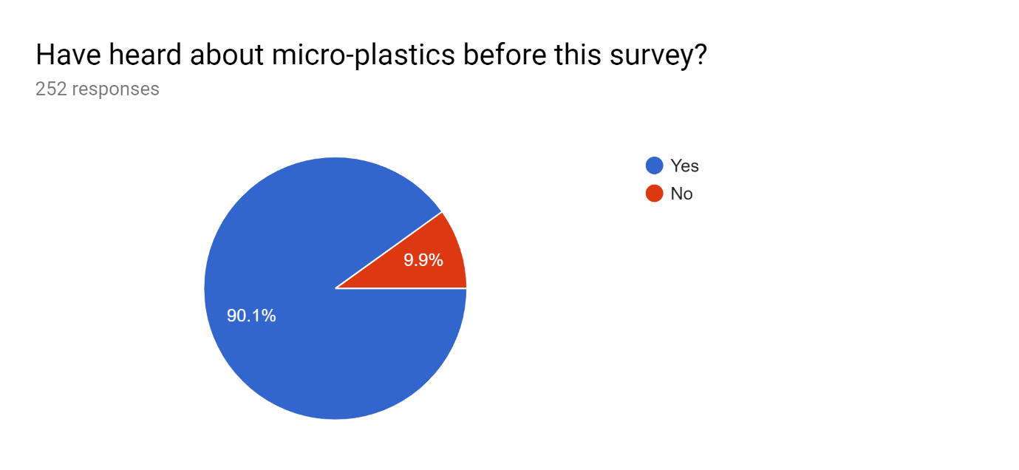
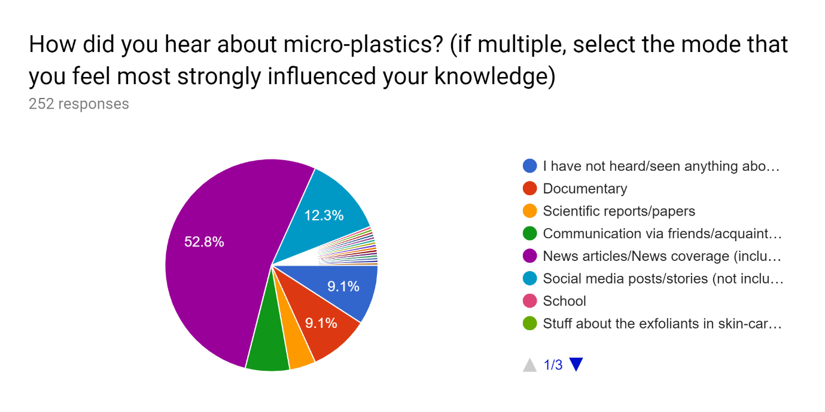
Could you specify more about where you feel you have heard about micro-plastics before (type x if you have not previously heard of them):

52.8% of people asked heard about the microplastics via the news, whereas 12.7% heard about them via social media and 9.1% from documentaries. 4.8% (12 participants) heard about microplastics from scientific sources including reports and lectures. Responses:
X
x
TV
Greenpeace
David Attenborough
The Guardian
BBC news
Blue Planet
Newspapers specificalle Daily Mail.
Radio
The Economist
A Facebook video on micro plastics research
Twitter / news etc
newspaper
Small pastic particles that get into the ecosystem and are then consumed and make their way up the food chain. They can cause lots of damage to larger organisms
In biology (I think) class at school
I follow Zanna Van Dijk on Instagram. She is co-founder of a swimwear company which is focused on producing ethical products which don't harm the ocean. In one of her stories she spoke about all of the issues they had taken into account when creating swimwear and one of these were micro-plastics.
a video on facebook talking about the micro beeads in facewashes that go into the water system
The little bead thingies!
I think a video on Facebook
News articles shared on environmental pages
school
Social media, and other people
BBC News, Facebook
I heard from a fashion student, who is heavily invested in the environment and dreams about the abolishment of fast-fashion - believing that you can have ecological clothing lines.
News articles
News articles on social media feeds
think it was a greenpeace article, or some sciencey/campaigny organisation
Word of mouth, news articles, friends. It’s a problem we’re aware of
After doing a research project on plastic consumption
Wrote an essay on them kast year for my corse
WI resolutions
Science articles
Articles about them in the Guardian
probably bbc news or the guardian
Greenpeace news
NEWS, MY OWN RESEARCH TOPIC, SCHOOL
Facebook and BBC
my friend does marine biology and was studying them in fish
I’ve heard about micro plastics in the context of glitter around Christmas time last year
Microbeads in face wash killing fish in the sea
I volunteered at a marine biology organisation in Mozambique and I learned about them there
Article on twitter
netflix documentaries
In articles about food and cosmetics
in newspapers and the greenpeace newletter
Recent scientific news pieces about their impacts on marine animals etc
BBC article on environmental effect
I think Obama banned them?
News articles online
Facebook Posts
News articles on BBC etc.
national geographic, vox
During A level biology
BBC news, Facebook posts from conservation pages
Articles about microplastics being banned in cosmetics
Twitter, people warning of their harm.
Only briefly discussed in a few geography lectures on environmental contamination
Environmental instagrammers
mainly from social media and the news but also from people around me like family and friends
Radio, newspapers and bbc news tv
Wildlife tours
Radio 4 almost certainly
It's a topic frequently discussed at home,; we also watch documentaries. We are involved with ocean cleanup, and are producing plant based bottles and food packaging instead of plastic;
The Guardian (I think ...)
Newspaper articles
From environmental news articles and from people who work in the environment sector
TV documentary
Social media 'news'
Initially with bbc news coverage on micro plastics in face wash then I did my own research
A few years ago there were suddenly a lot of news reports shared on social media about how bad they are for the environment
Academic literature but also a lot in the media
Scientific paper/news articles related to their effect on marine life.
News pieces & Facebook shares
Random articles in fb
Can't remember
Plastic ocean
I studied zoology at university and a lot of my friends are keen marine conservationists and lectures and field work was based on microplastics.
BBC news articles/ AJ+ posts on Facebook
My biology degree, instagram, bbc news
Had to do a school presentation of a research paper about the 'a plastic ocean' documentary
Mostly via Internet news sources probably mostly the Guardian) and social media
Scientific article through a mailing list
News papers
Not good for the environment
Working at lush!
Through Facebook pages like Now This I believe
There have been a lot of shared articles in my social media news feeds in recent months.
BBC News articles
Bbc news coverage
Articles shared via social media with links to science and news pages
In relation to them being present in fish we eat
David Attenborough
news articles saying they're everywhere
MCS group on facebook
Friends. And clean kilo fb page has info on syntheics from clothes
Tv news programmes
Tv documentries
i think i've heard people i know talk about them ending up in the ocean but i can't remember much detail
APES class in high school
OTHER (119)

